Classification and Regression, from linear and logistic regression to neural networks

**Evaluation of project number: 2**

**Name: Mirabella Simone**

**ABSTRACT**

**Regression and classification are two main goals when it comes to supervised machine learning. We define regression a**s the process of identifying the missing or unavailable numerical data for a new observation, and **c**lassification as the process of identifying the category or class label of the new observation which it belongs to. The aim of this project is to explore these two techniques with Neural Networks, and it will be shown that it is a powerful tool in terms of accuracy and implementability as well. A neural network is a computational learning system that uses a network of functions to understand and translate a data input of one form into a desired output, usually in another form. The report describes how a Neural Network works and explores its components, such as weights, biases, activation functions, etc. It will also be focused on assessing how the parameters contained in a Neural Network, such as the learning rate, affect its accuracy.

**KEY WORDS**: Linear Regression, Logistic Regression, Gradient Descent, Neural Network

**INTRODUCTION**

**Neural Networks (NN) are systems that** use the processing of the brain as a basis to develop algorithms that can be used to model complex patterns and prediction problems. The logic behind **NNs tries to reproduce the way our brain works: we receive external information (inputs) from the world that surrounds us, and the dendrites of our neurons process that information, convert it to an output and pass it through the axon to the next neuron. Moving from a neuron to another, the inputs that are received in the beginning are processed until an output is obtained out of them.**

**The way NN are structured mimics the neuron systems as it has been introduced: we develop NNs with an input layer, which correspond to the signal we get, and we will obtain a final output, represented by the output layer. Between these two layers there are one (even zero, if desired) or more hidden layers, made of one or several neurons, which handle and manipulate the original input and the outputs of every internal layer to derive the final output. This is done by associating different weights (importance) to each input, and also by different activation functions, that are the way the network manipulates the inputs.**

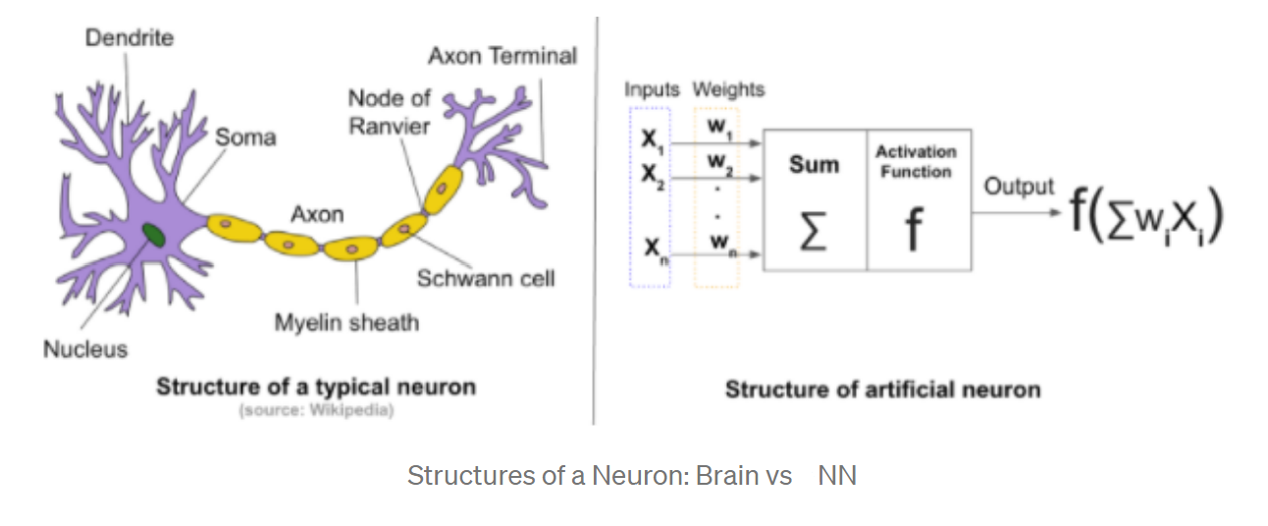

**Neural networks have been applied to many diverse fields in the past years: from pattern recognition/classification to image processing, stock market predictions and many other examples, they have been a central topic thanks to their adaptability, implementability and simple structure, which will be analysed in the following paragraphs of the report. What will follow is an introduction of feed-forward neural networks, the mostly encountered and used NNs in many diverse applications.**

**When we work with NNs, we will need to train them: training a Neural network means finding the appropriate weights of the connections between the different layers, thanks to a specific algorithm. The mostly used algorithm for this purpose is back- propagation, which** will be explained **in the report as well. Before doing this, it will be necessary to introduce the gradient descent methods, since gradient descent is the way that is used to find the best values for the weights, which will be iteratively modified with algorithms such as the already mentioned back-propagation.**

**FEED-FORWARD NEURAL NETWORKS**

As introduced before, neural networks, as the name implies, are inspired from their biological counterparts, the biological brain and the nervous system. While the brain can learn and adapt by itself, the artificial network will obviously need a software behind that teaches him how to handle the information.

The basic block of NN is a *neuron*. Neurons inside the network are connected with each other through *weights*: they receive ‘weighted’ information via the connections from the other neurons and produce outputs by passing the weighted sum of those input signals through an *activation function*. We define a neural network as ‘Feed-Forward’ (FFNN) when the connections between the nodes do not form a cycle, that is, the information always moves in one direction, never going backwards. When cycling happens, we will talk about recurrent neural networks (RNN), which are not a topic of this report.

Neural networks are, as previously anticipated, arranged in the form of layers: they always have an input and an output layer at the boundaries, and can have zero to an unspecified number of hidden layers between them. They will therefore be referred to as single- or multi-layer networks.

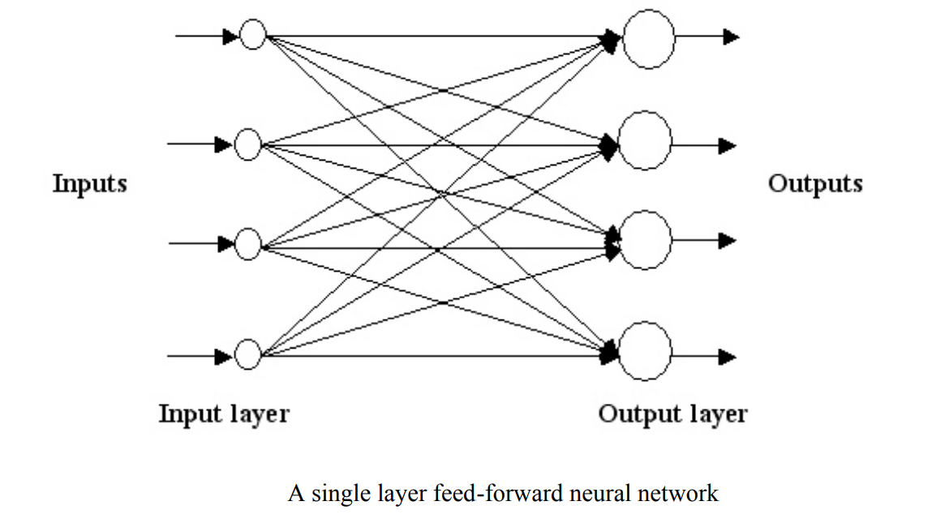

The figure above is an example of a fully connected feed forward neural network, where input signals are passed directly on the output layer via some weights.

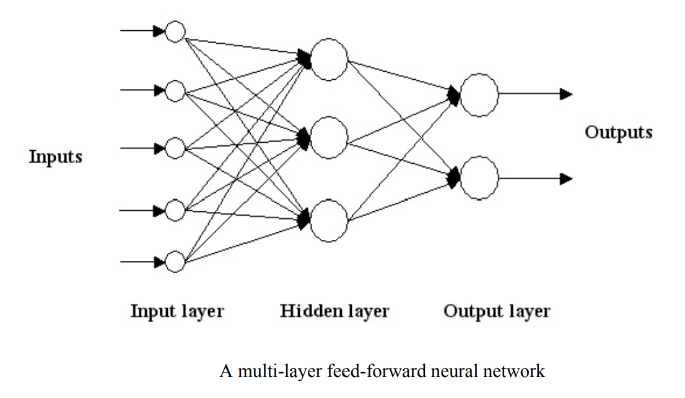

Differently, this last figure shows an ‘hidden layer’ between the input and the output ones. This layer is used to intervene on the input to extract the information in a more useful manner.

As already said, the main feature in neural networks is their learning capability: from the data, a neural network can learn and improve its performance.

“Learning is a process by which the free parameters of a neural network are adapted through a process of stimulation by the environment in which the network is embedded. The type of learning is determined by the manner in which the parameter changes take place.” [Haykin]

Before talking about the back-propagation algorithm, it is below reported a digression about Gradient descent, a method that is central in NNs. To show the power of this method in terms of regression, it will be compared to ordinary least squares (OLS) optimization. An extension on ridge regression will be reported as well.

**GRADIENT DESCENT**

During the learning, or training, procedure, the performance of the network is always kept into consideration. The network will be trained so that a specific loss function is minimized, and the NN fits the given dataset without overfitting. The loss function depends on the adaptive parameters of the network, that are the weights and the biases.

The weights control the strength of the connection between two neurons and decide how much influence the input will have on the output. The biases are constants that are additional inputs into the layers. They are used to adjust the output and allow to shift the activation function to either right or left.

If we look at the univariate regression scenario, what we have is something like:

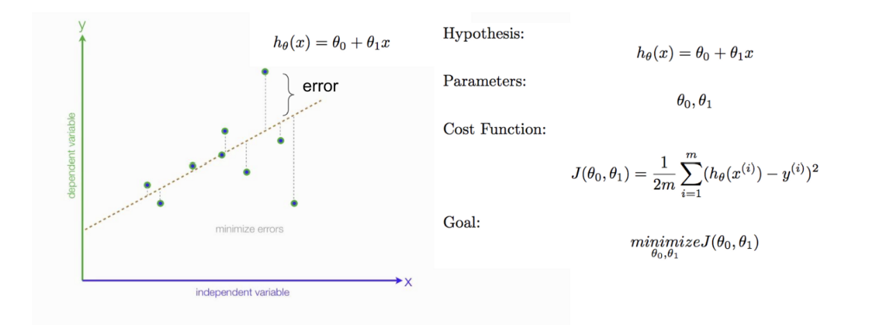

Where the ‘hypothesis’ is the regression line, that is the model used here to fit the data, and where θ0is the bias and θ1 the weight. The goal is, as said, to minimize the loss/cost function, and the aim is to find the values of the parameters that allows us to do so.

Gradient descent methods are efficient optimization algorithms that attempt to find a local or global (hopefully) minimum of a function and are widely used in NN. This method runs iteratively to find the optimal values of the parameters corresponding to the minimum value of the given cost function, using the concept of derivatives.

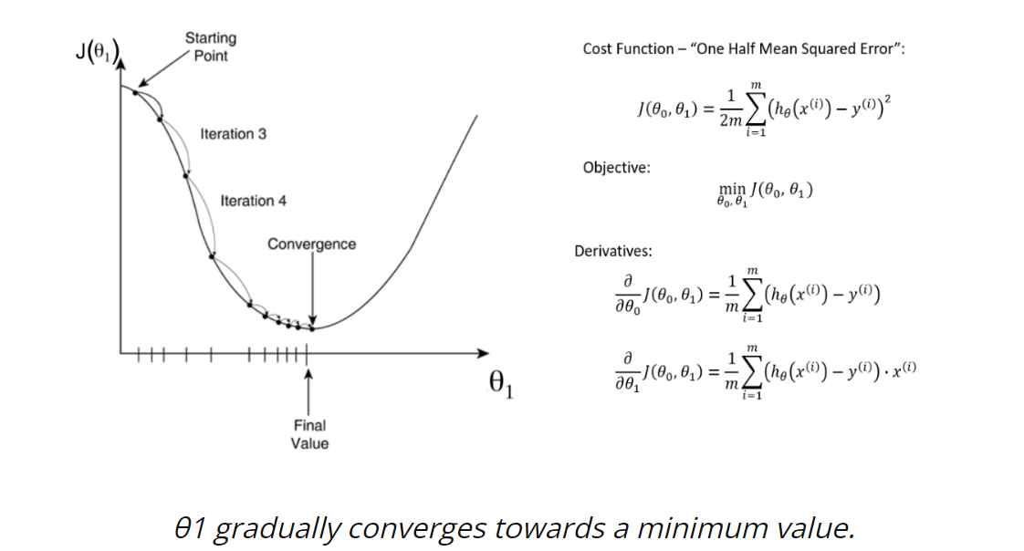

The derivative is a concept from calculus and refers to the slope of the function at a given point. We need to know the slope so that we know the direction (sign) to move the coefficient values to get a lower cost on the next iteration. The derivative of a function (in our case, J(θ)) on each parameter (in our case weight θ) tells us the sensitivity of the function with respect to that variable or how changing the variable impacts the function value. Gradient descent, therefore**,**enables the learning process to make corrective updates to the learned estimates that move the model toward an optimal combination of parameters (θ).

Starting from random or fixed values for the parameters, at each iteration the partial derivatives, that compose the gradient of the loss function, are obtained with respect to each weight and the bias. Then, each parameter is updated using the corresponding partial derivative of the gradient and a hyperparameter named *learning rate*. (An hyperparameter can’t be learned by the network and must be hand-tuned). This additional parameter gives us control over how large the steps from one point (one set of values on the parameters) to another should be. The weights and bias are then iteratively updated until the error obtained from the cost function reaches a certain threshold. And that’s how gradient descent methods work.

Choosing a proper value for the learning rate is essential to avoid both gradient’s *explosion* (the minimum is missed) and *vanishing* (the minimum is reached too slowly, or not reached at all). Proof of that will follow in the next pages.

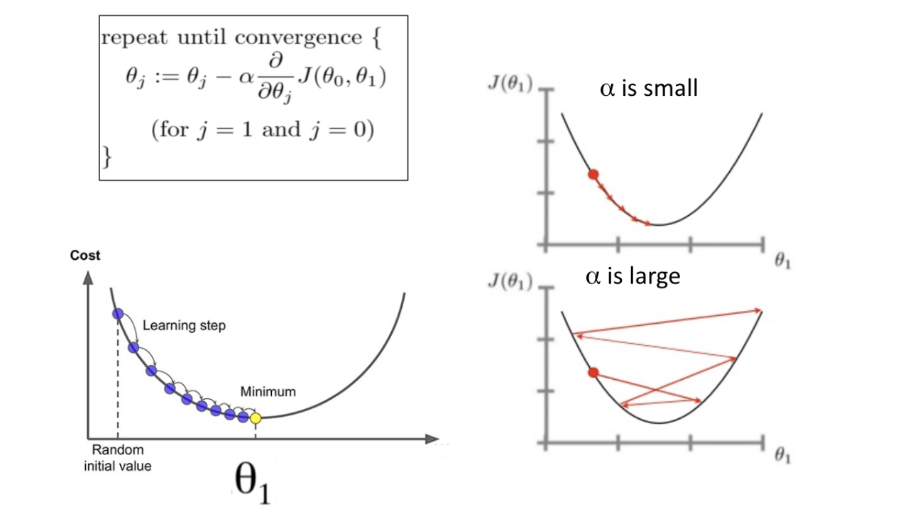

In this report, different methods of gradient descent have been implemented. Even though using the whole dataset (called batch) is extremely useful for getting to the minima in a less noisy or less random manner, the typical Gradient Descent method can become computationally very expensive when working with large dataset. For this reason, the *stochastic gradient descent* (SGD) and *the mini-batch gradient descent* have been used.

Unlike the typical Gradient Descent optimization, instead of using the whole data set for each iteration, with SGD we can use the cost gradient of a reduced example at each iteration. SGD is technically referred to the use of 1-example batches, but it is more common to use bigger batches for computational reasons and better optimizations as well.

Since it commonly uses only a single sample, SGD generally comes with a high variance, which causes the loss function to fluctuate heavily. Therefore, Mini-Batch SG is often more used: a batch of a fixed number of training samples (less than the full dataset) is considered and used to obtain the gradient and the estimates of the parameters. This helps to have more stable (less variant) results, obtained faster and efficiently.

**Note 1**: another hyper-parameter that need to be checked is the number of *epochs*. An epoch is a training iteration when the NN goes through all the training set and therefore, when using mini batches GD, an epoch is completed after the NN goes through all the batches. We will check also how a different number of epochs affects the results of the GD.

**Note 2:** another hyper-parameter can be added as well, and it is the *penalty*, or regularization, *parameter*. This is added in case we implement Lasso or Ridge regression, which are regression methods used to account for smaller variance (but higher variance) in the model. Additionally, Lasso can also work as a variable selection technique.

The following image shows how the gradient descent works and how it is used to update the weights and bias:

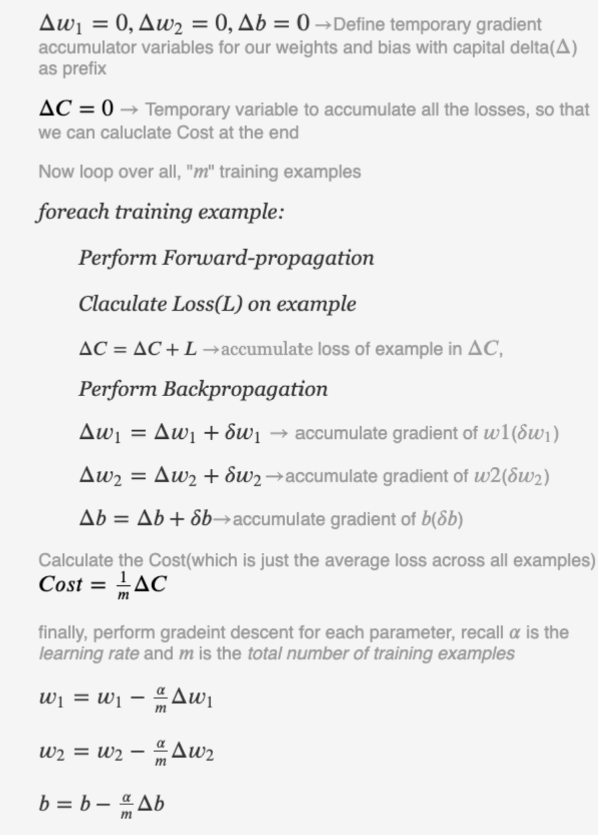

A dataset containing the temperature registered at different dates and in different countries during WW2 has been used to show how the gradient descent methods work. A comparison between the methos and different choices of the learning rate has been done as well.

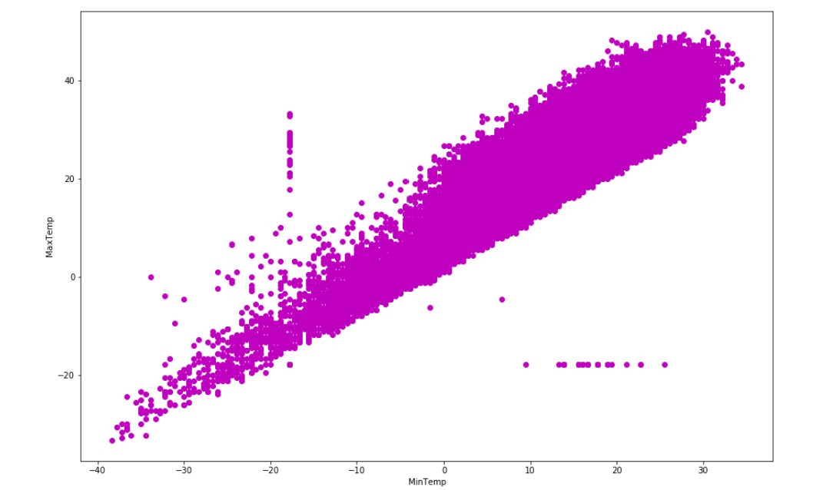

As we can see, the two variables seem to have a linear relation, so it makes sense to use linear regression to fit the data.



As we already said, the typical (batch) GD is the one that works the best in terms of errors, since it uses the whole dataset at the same time, but it comes with a long time needed for the implementation, as shown below:

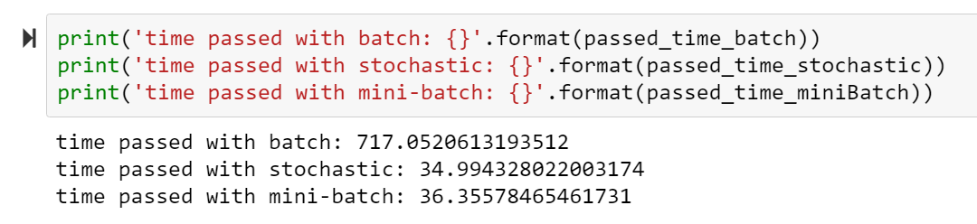

As we can see, here ‘the regular’ GD method took more than 20 time to reach the best MSE that we were looking for, and this value is only 0.005 points (approx..) lower than the values obtained with the other two variation.

**NOTE** the code has no seed in it, so re-running it will not give the same results as the one I showed, but the difference in time is still there (maybe not as high but will still be important).

It is also possible to observe that, as said, the stochastic variation comes with more variability, which generally leads to prefer the mini-batch variation more than the others:

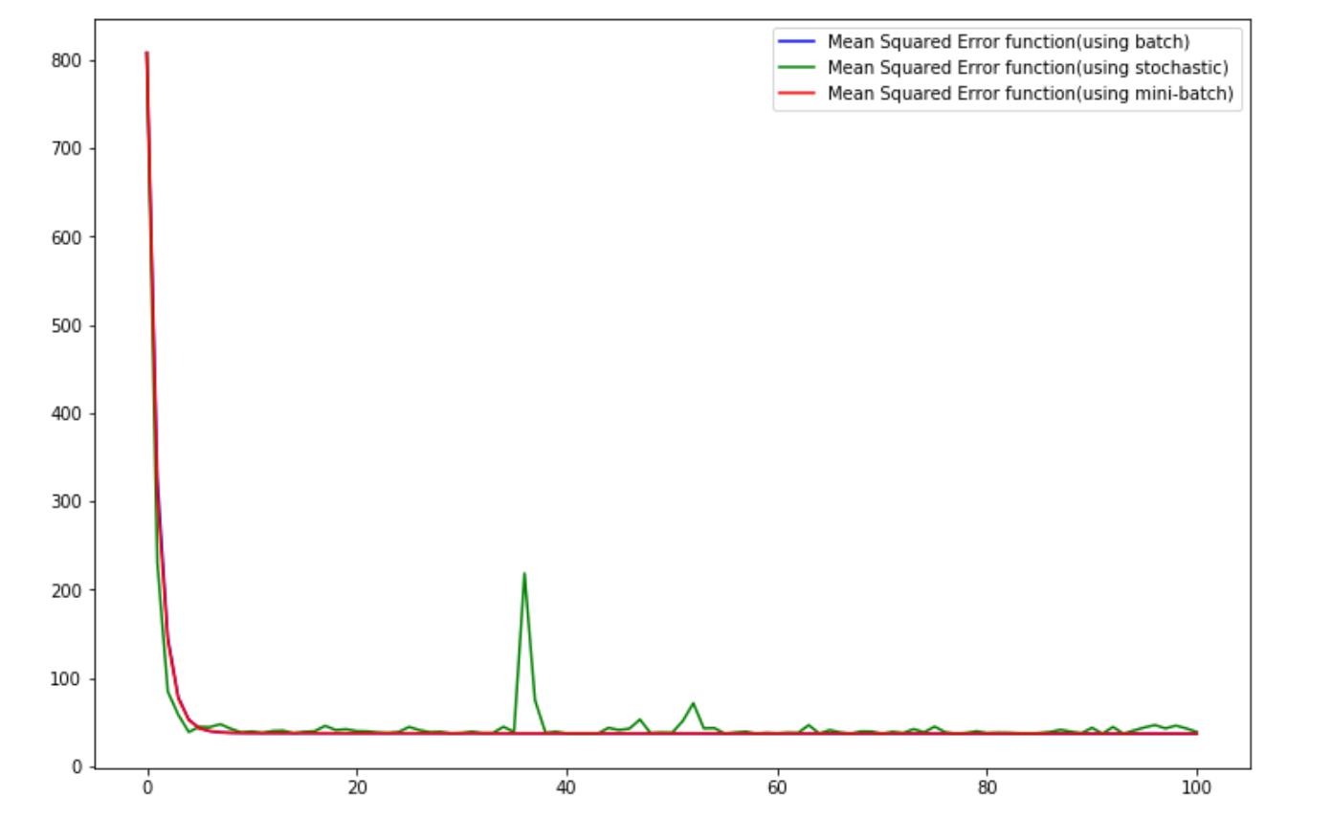

What is also worth noticing is that values close to the best MSE are reached after few iterations (around 15/20), and the remaining iterations simply lead to values that are slightly lower. That means that the gradient descent, in all of its variations, is a very powerful that allows to reach almost optimal solutions in very few steps.

When talking about the GD, two main parameters come into attention and might influence the results significantly: the learning rate and the regularization hyperparameter. As already said, the learning rate conditions ‘how big’ the steps in each iteration are. A smaller learning rate will lead to the minimum slowly, but if a too large value is chosen, then the algorithm might miss the minimum because it will surpass it. Therefore, this parameter is the most important one when it comes to GD.

When gradient descent methods are applied to methods such as ridge or lasso regression, then the tuning parameter lambda becomes another fundamental value to check, since it will lead to give more or less importance to certain variables, and this will influence the results of the fit (in terms of errors, predictions...). For this reason, I have implemented the mini batch gradient descent for different values of both the learning rate and lambdas, to check how much the MSE and the estimates of weights and bias change:

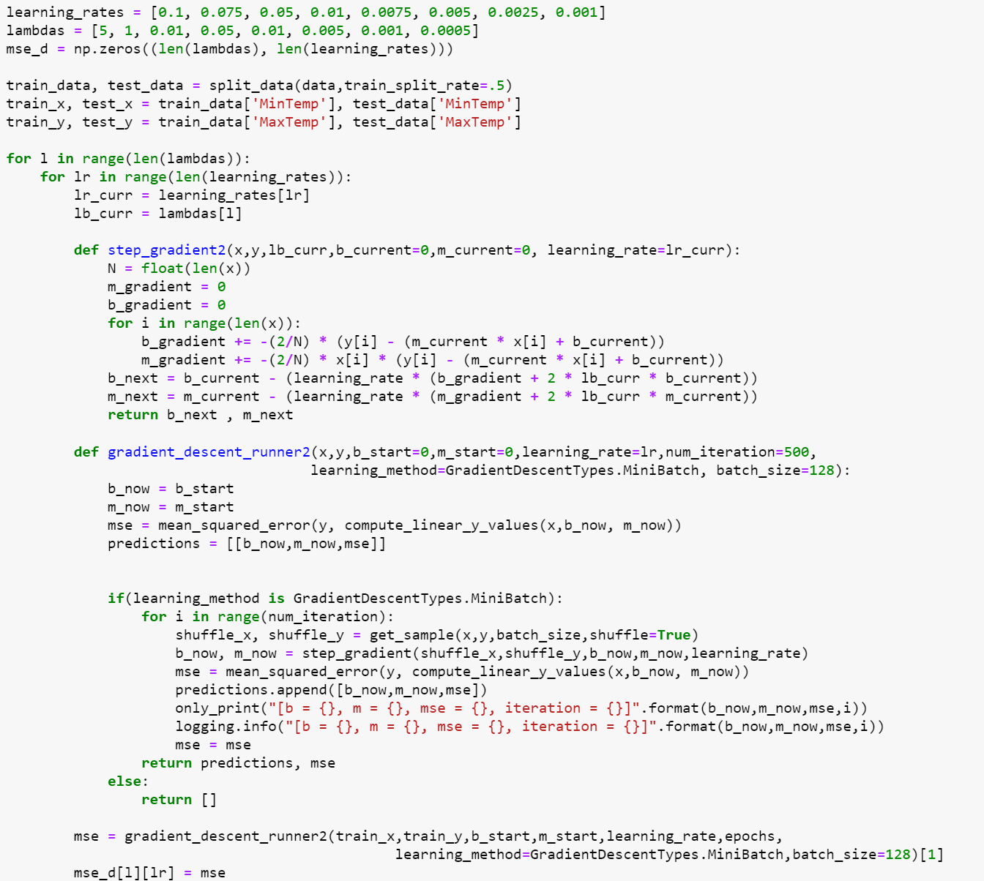

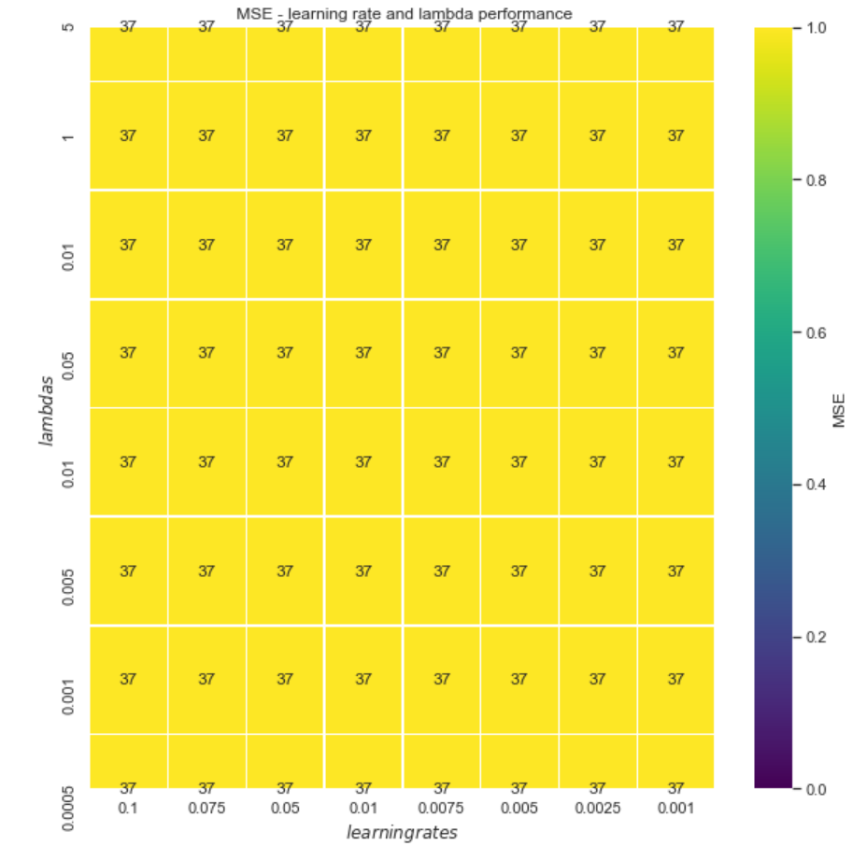

Note that this heatmap is not really useful to read, but it still tells us that values for the rate and lambda among the set of chosen value give results that are almost identical. We could try some more values to see if something changes:

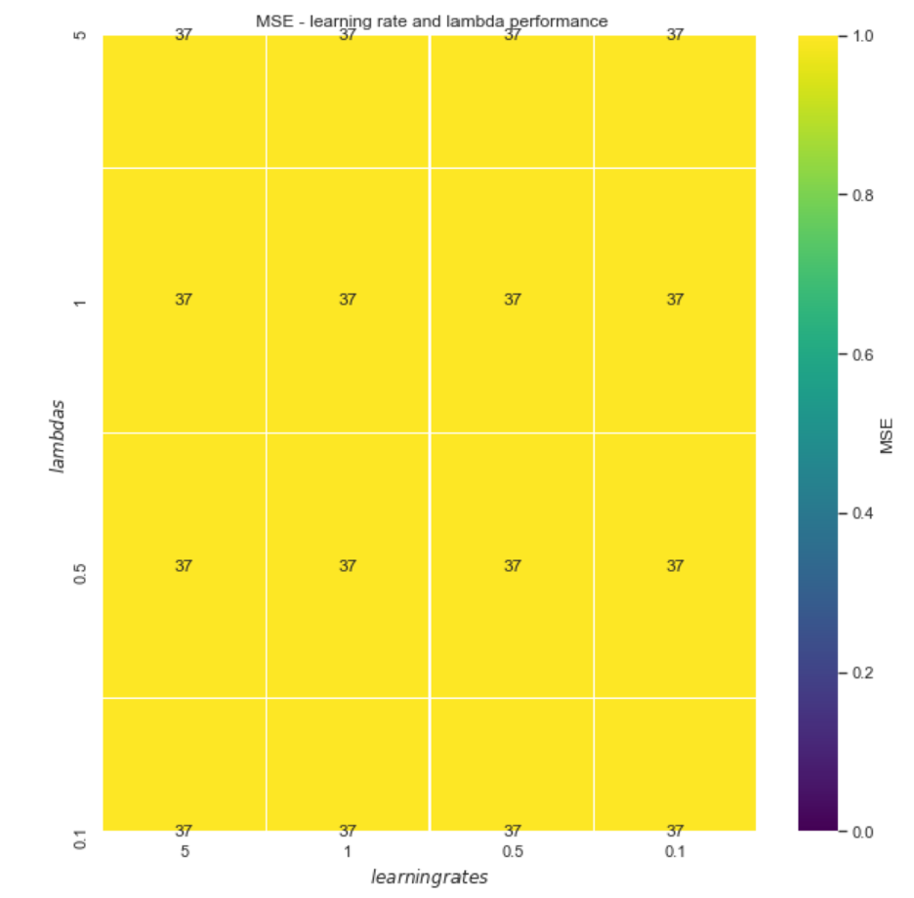 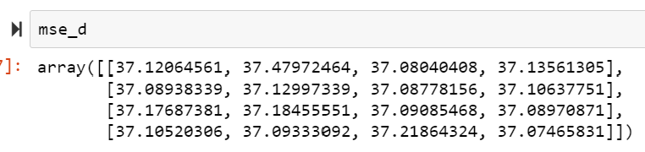

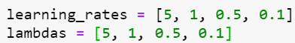

Again, even with higher values for the rate and lambda, the results do not change much. If we want to be meticoulous though, we could look at the decimal part and say that in this case the best results in term of MSE are obtained with lambda equal to 5 and learning rate equal to 0.5, corresponding to the value 37.08040408.

The three variants of the Gradient descent that we saw above are not, anyway, the only methods one can use to minimize the cost function. In fact, many more methods have been developed, like the SGD with momentum (SGDM), ADAGRAD,.…

**SGDM**: we add a momentum term to the equation to update the weight vector, where the momentum term is a moving average of our gradients. The momentum term is used to prevent the oscillations that naturally come in SGD and to reach the minimum faster than SGD since it accumulates the gradient of the past steps to determine the direction to go

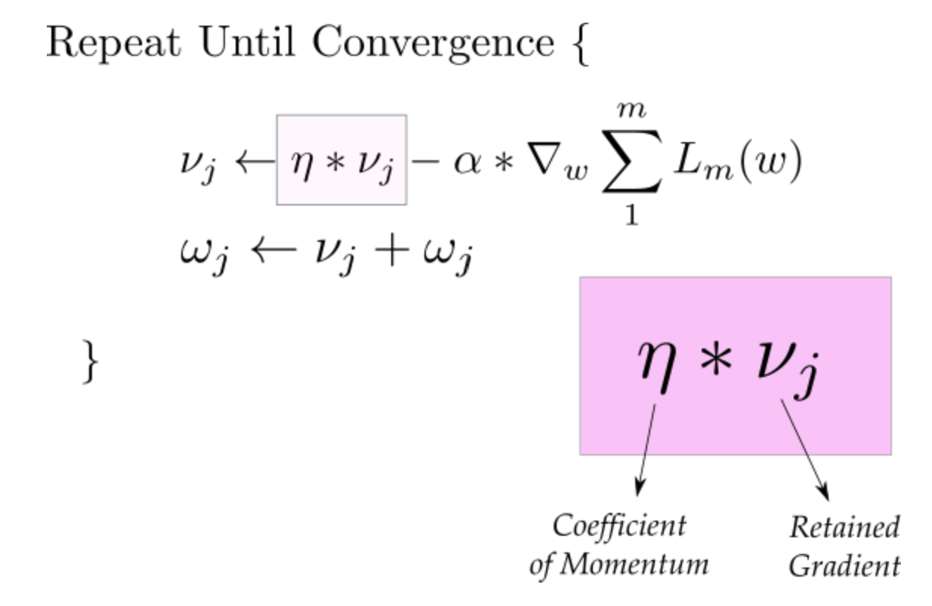

**ADAGRAD**: this algorithm adapts the learning rate to the parameters, performing smaller updates (lower learning rates) for parameters associated with frequently occurring features, and larger updates for parameter associated with infrequent features. This is used a lot with sparse data.

There exist many other methods, like ADAM, ADADELTA, RMSprop...

An implementation of these different methods will follow from Page 22, in particular in Page 33.

As already stated, the Gradient descent is a key point when talking about NNs. The way it has been presented, and the analysis on different values of the learning rates, hyperparameters, epochs and batch sizes should be enough to now dig in the main topic of the report, Neural Networks.

Let’ now present the main components of Feed Forward Neural Network. After that, it will follow a development of the method behind Neural Networks, and a proof of how powerful this algorithm is, both in term of regression and classification.

**THE LAYERS**

As said before, a Neural Network is determined by the different layers it has. Let’s now consider a simple NN, with one hidden layer, and explore it:

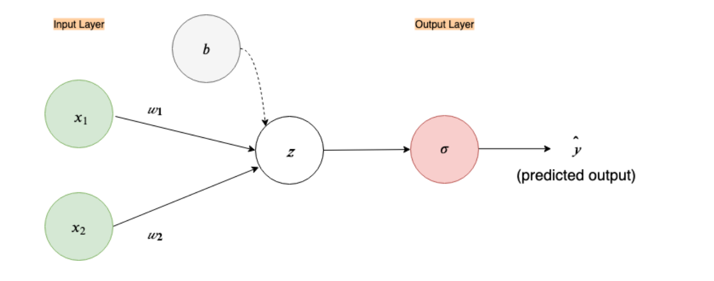

The first layer is called *input layer.* It contains the *nodes* (i.e., the inputs) corresponding to our features, X1 and X2 in this case.

The arrows moving from the green nodes to the white one correspond to the *weights,* and they represent the weight vectors. They dictate how much influence each of the input features should have when computing the next code. Thinking about linear regression, the weights have a similar role to the slope.

The grey node is representing the *bias*. Once again, this term tells us that all outputs should have an additional term so that even when the output in zero, it is still possible to obtain information from that output.

**NOTE**: Both the weights and the bias need to be initialized to certain values

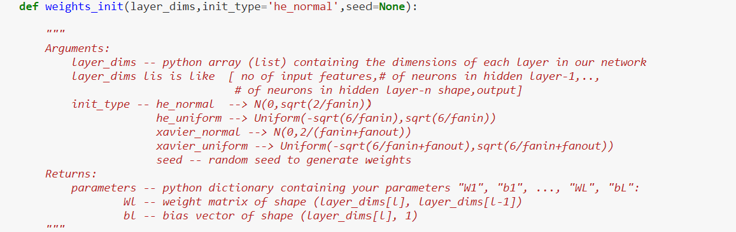

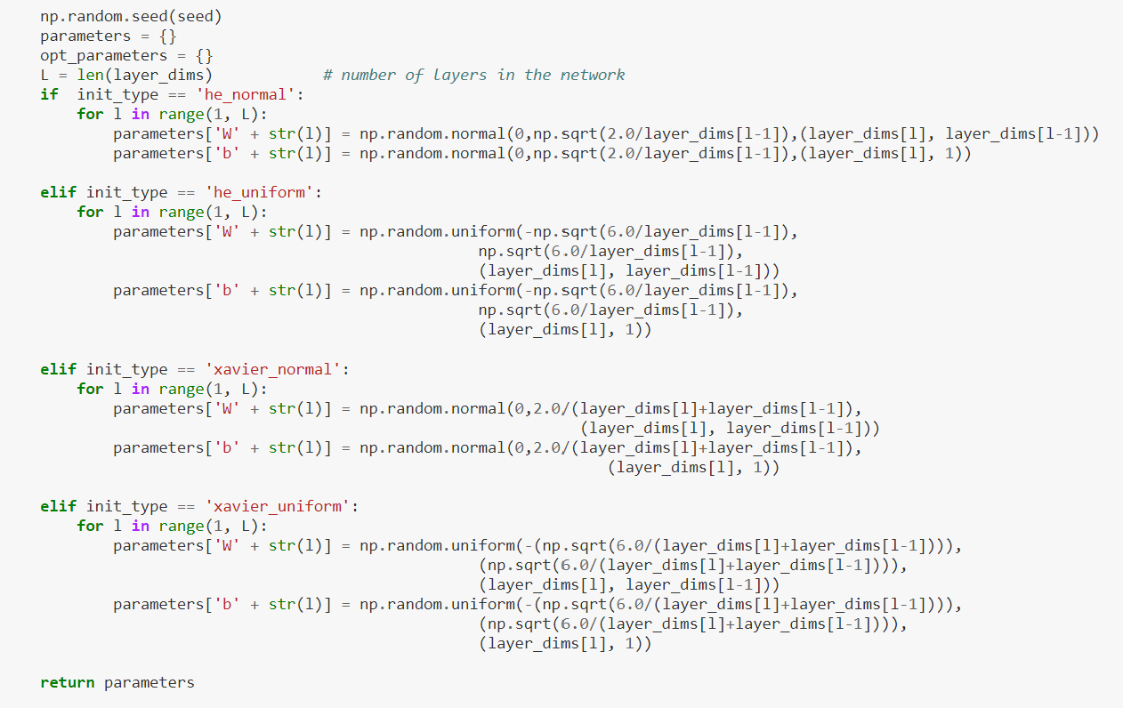

In the code above, that is the one I will use in the classification part, four different possibilities are given for the initialization of the parameters: the He and the Xavier initialization, with normal or uniform distributions. The *He normal* is probably the most used in general: we initialize the weights as randomly normally distributed and multiply them by a constant that considers the dimension of the layer to which the weights refer. The *Xavier* initialization is the weights initialization technique that tries to make the variance of the outputs of a layer to be equal to the variance of its inputs, and is generally used with the sigmoid function, while the He usually comes with the *RELU* function, that was introduced many years later than the sigmoid.

The white node represents the *hidden layer*, which can be composed of more than one node. It takes the inputs coming to it and applies a function on these inputs. This function is called activation function, and it can be different from hidden layer to hidden layer.

Finally, the red node corresponds to the *output node*, which is obtained by a chosen activation function applied to the output of the last hidden layers, if there is any, or the input layer. When working with classification, for example, the activation function is usually the sigmoid function.

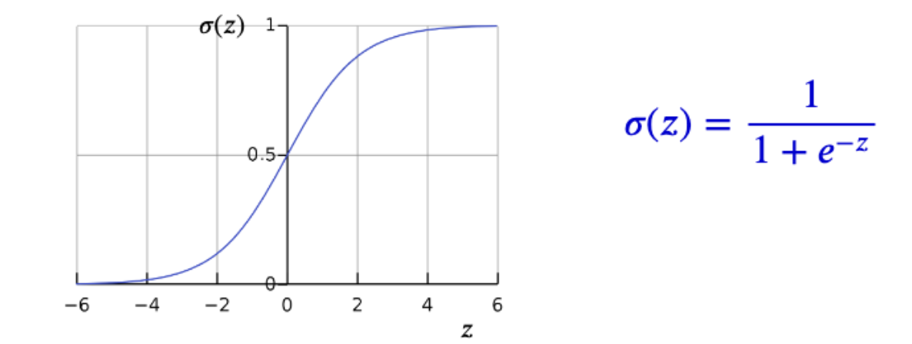

This function is often chosen for binary classification since it allows to set the output equal to zero whenever the output probability is lower than 0.5 and 1 otherwise. How we can obviously understand, different goals lead to different choices.

**THE ACTIVATION FUNCTION**

An *activation function* (AF) is a function that generally outputs a small value for a small input, and vice versa for large inputs. Therefore, this activation function “fires” the input only if they are large (significant, we may say) enough, otherwise it just returns 0 (or a slightly higher values, as we’ll see). These functions are useful in NNs since they can add non-linearities into the network, which allows it to learn and return accurate outputs.

As already said, a very much used activation function is the sigmoid, but others like the RELU, Tanh, Softmax, are common as well. A comparison of how the results change as the AF changes will be shown in the following pages.

These functions are functions of the outputs of the pervious node, and their derivative will be used in the Back-propagation Algorithm (see later) to obtain the new weights and biases. The following image contains a list of different activation functions, their derivatives, and graphs (from [wiki](https://en.wikipedia.org/wiki/Activation_function)). As we can understand, the choice of the activation function will depend on the aim of the work, since different functions have not only different shapes, but also different domains, ant this would drastically change the output if not chosen in a clever way.

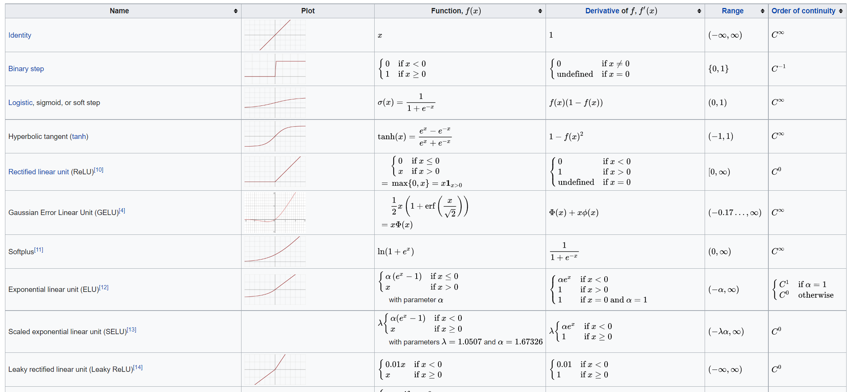

As said before, for example, the sigmoid is often used for binary classification problems for its ability to give results between 0 and 1. The identity (or linear) link in instead often used for linear regression problems.

Finally, before moving on to how the algorithm itself works, I’ll need to introduce another essential component of neural networks (and optimization techniques in general):

**THE COST/LOSS FUNCTION**

This function is a simple equation that tells us how far the neural network’s predicted output $\hat{y}$ is from the desired output $y$. As already seen while we implemented the Gradient descent methods, the loss will be calculated either on the whole dataset or as an average loss for all the mini batches in which the dataset has been decomposed (or in some other ways).

A function that is generally used as Cost function is the Mean squared error. This is chosen because it is obtained as a sum of squared errors: in this way, the errors can’t counterbalance, and we can make sure to have a trustable idea of how the analysis is proceeding. Additionally, the first and second derivatives of the MSE can be obtained with almost no problem, which for example can’t happen when we use the absolute value to assess the distance between the values we have and those we predicted.

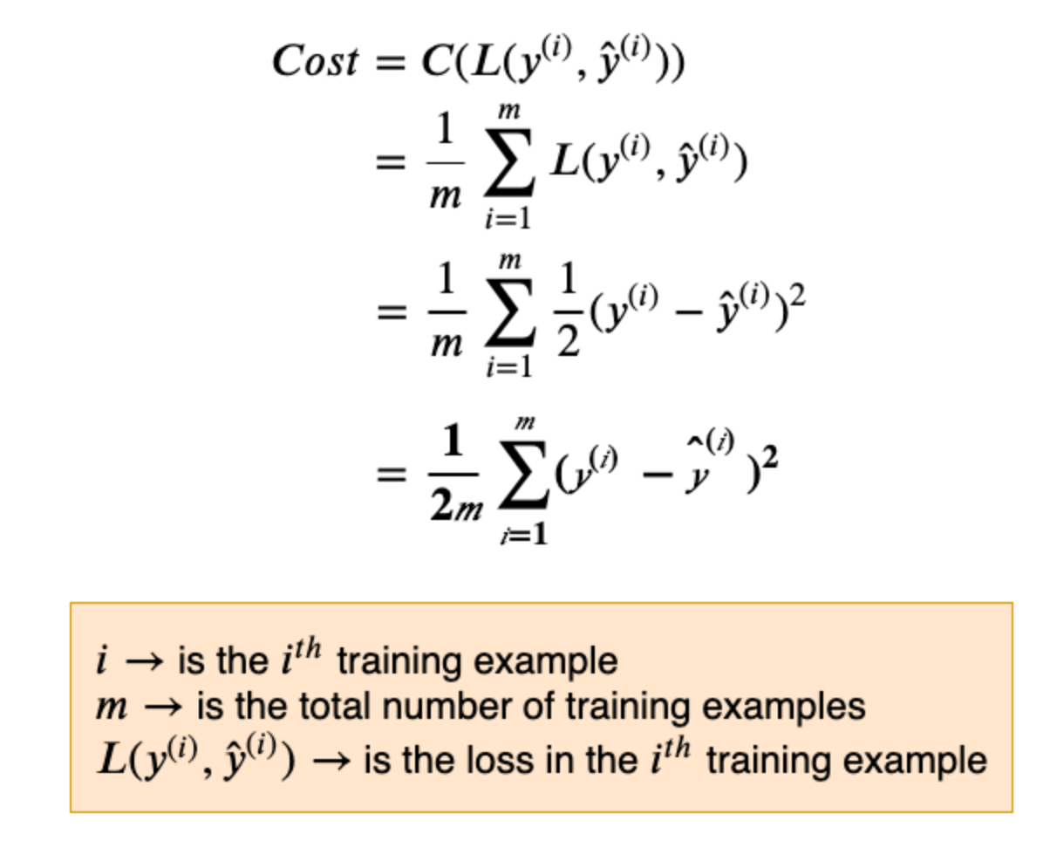

The cost function helps to minimize the vertical distance between the data points and the predictions, that is, the loss function is a measure of the error made from the network (or from a fit, in general). To move towards the minimum we are looking for, the loss function will be derived with respect to the weights and bias (contained in the predicted term) and its gradient will be used to update the parameters (w and b) of the Network.

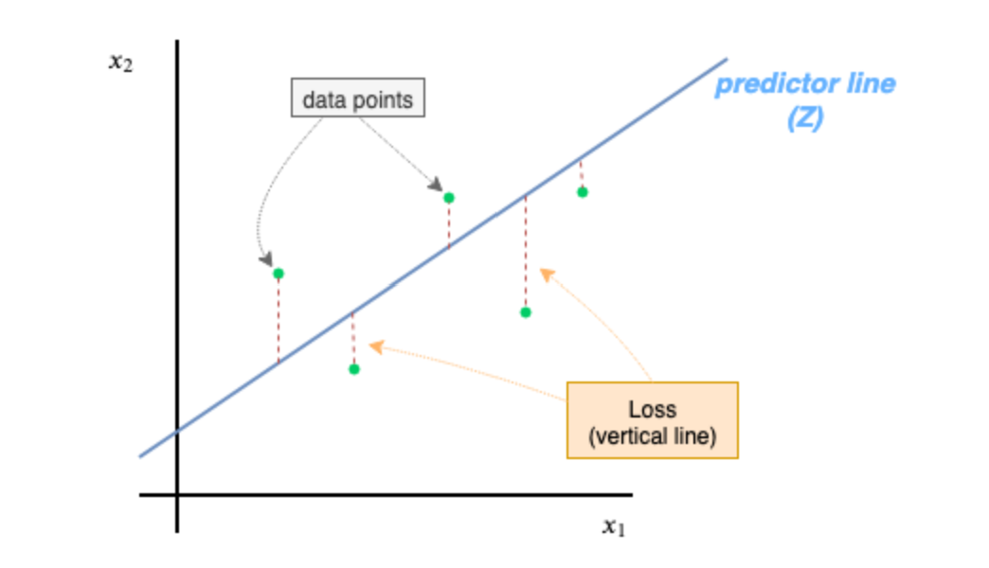

In the code below, the cost function is obtained using the log of the sigmoid function, since this cost is the one used for the classification problem.

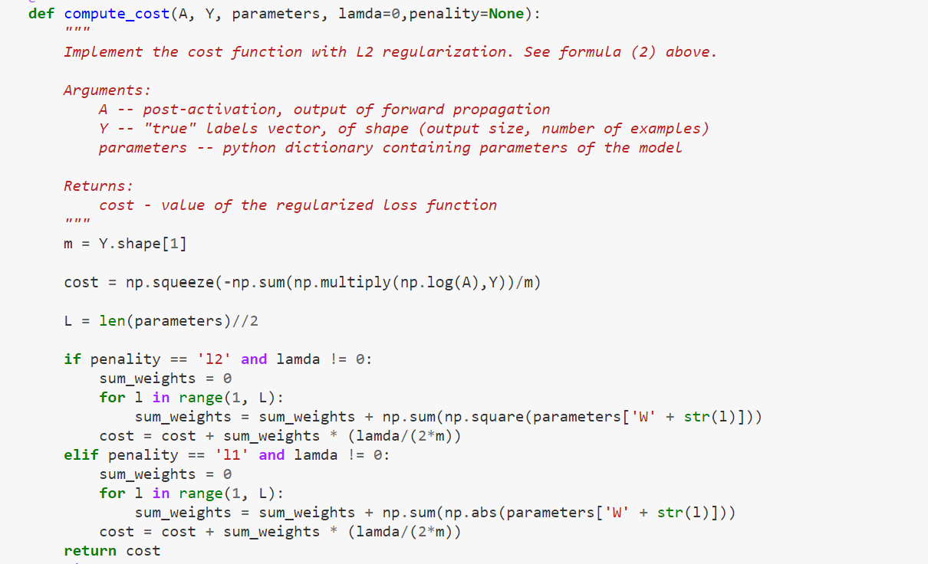

In this code, a possible regularization has been considered as well. Therefore, the cost has been written both for the l1 and the l2 penalties, to assess if adding them can lead to better results.

Let’s now see how these components interact with each other and how the algorithm works in practice. To do that, I will present the results both for the regression and the classification scenarios, with the implemented functions and results.

**THE METHOD**

The way neural networks work is quite simple and has been somehow anticipated in the following pages when their components have been introduced. Let’s now sum up what we’ve been going through and look at some applications. There will be both results on regression and classification, but the focus will be mainly on classification examples since that is the fields where neural networks are used the most.

As already said, we are now implementing Feed Forward Back Propagation Neural Network. Let’s see what they are about:

Before working with the network, there are some values that we need to initialize: The number of layers, the number of neurons in each layer, the initial weights and biases, the activation function to use for each layer and the hyperparameters. Once this is done, the network can start working:

In the first step, moving from the input to the first hidden layer, all the input units are multiplied by their weights to the first hidden layer, then the bias term is added. Therefore, we have a linear combination of the inputs, Z1= W1* X1 + W2 * X2 + … + Wp * Xp + B1

Secondly, the activation function is applied to the linear equation Z1. As already said, this function is used since it allows to inculcate nonlinearity in the model.

This process is done for each hidden layer, until we reach a final output. This part is where the *feed forward* name comes from: we never cycle, always move from a layer to the next one.

Once we are left with the output, it is time to teach the NN. The output is indeed used to calculate the error, i.e., the difference between the actual value and the predicted one (out output). If the error is over a certain threshold, then we need some steps to minimize it. At this point, Back Propagation comes in.

**BACK PROPAGATION**

*Back propagation* is the process of updating and finding the optimal values of weights which help the model to minimize the error. The weights are updated using an optimizer, that in our case is the gradient descent. Summing up again what we already saw in the SG section, to achieve the minima we:

1. Initialize randomly the weights and bias and calculate the error, as said above.
2. Calculate the gradient of the loss function with respect to the weights.
3. Calculate the new weights and bias with the one of the formulas from the different methods. For example, in the GD we’ll do it like this:

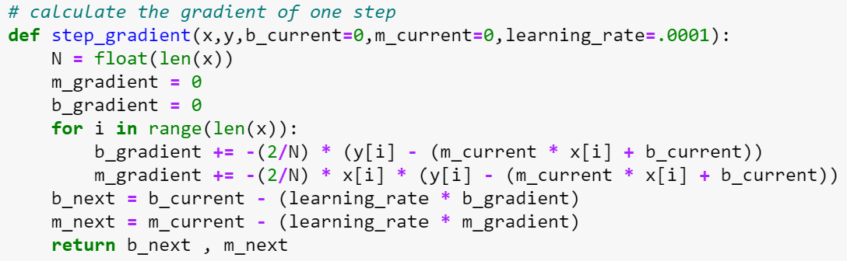

(As we notice, the learning rates come into play in this part of the algorithm.)

1. We repeat this process of calculating the new weights and corresponding error until the error reaches a threshold, that is, we reach the global minima or a value that is reasonably low enough to let us say that the loss is minimized.

**IMPLEMENTATION AND RESULTS**

The dataset I used the neural network on for the linear regression is the [Boston Housing dataset](https://keras.io/api/datasets/boston_housing/) (contained in Keras or sklearn). Instead, for the classification problem, I used the [Breast cancer data](https://scikit-learn.org/stable/modules/generated/sklearn.datasets.load_breast_cancer.html).

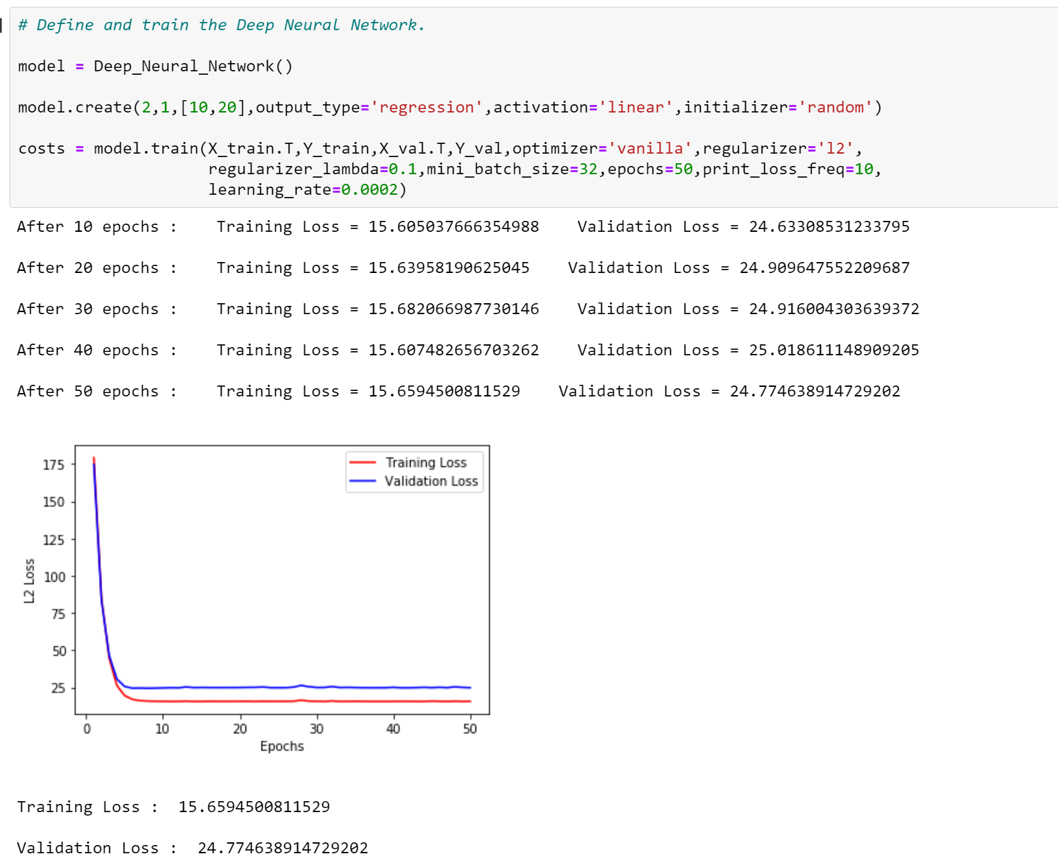

Figure 1

The picture above shows the results for a Neural Network applied to the train and validation data corresponding to the Boston Housing Dataset I have used in this case. We can see that the Network is learning from the data. In fact, starting from a MSE that is quite high (close to 65 for the test data and 70 for the validation), we can see that the error gets lower and lower, until it reaches 10 and 17. What is also interesting, is that the results on the test data are impressive as well, in fact:

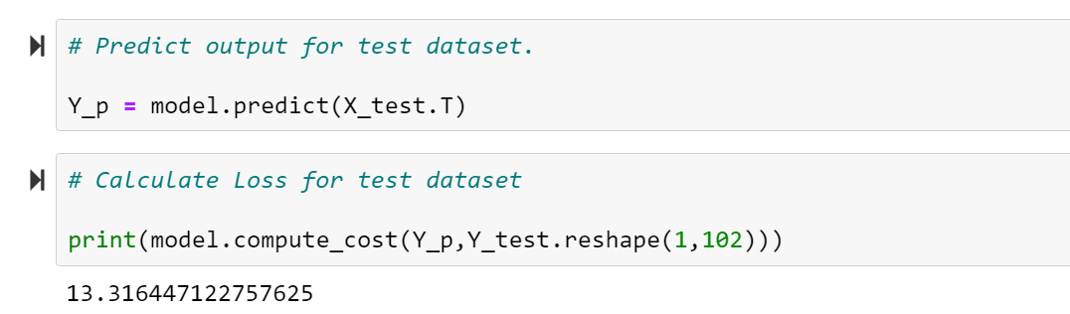

What it all means is that the Network can predict quite accurately the prices of the test houses (also considering that the features have high magnitude, which leads to higher MSE due to a higher variability in the data).

For as much as the Network is already showing its ability to learn, adapt and predict efficiently, we can still try to improve the results. In the situation above, we used the linear function as the activation function, and initialize the parameters as normally distributed. Additionally, I also included a regularization term (L2 regularization) and choose some values for the learning rate and the epochs. Once again, we can show that choice of the learning rate has a huge impact on the results.

When the learning rate is too low, the gradient can vanish, that is, the minimum is reached very slow, or not reached at all in this case:

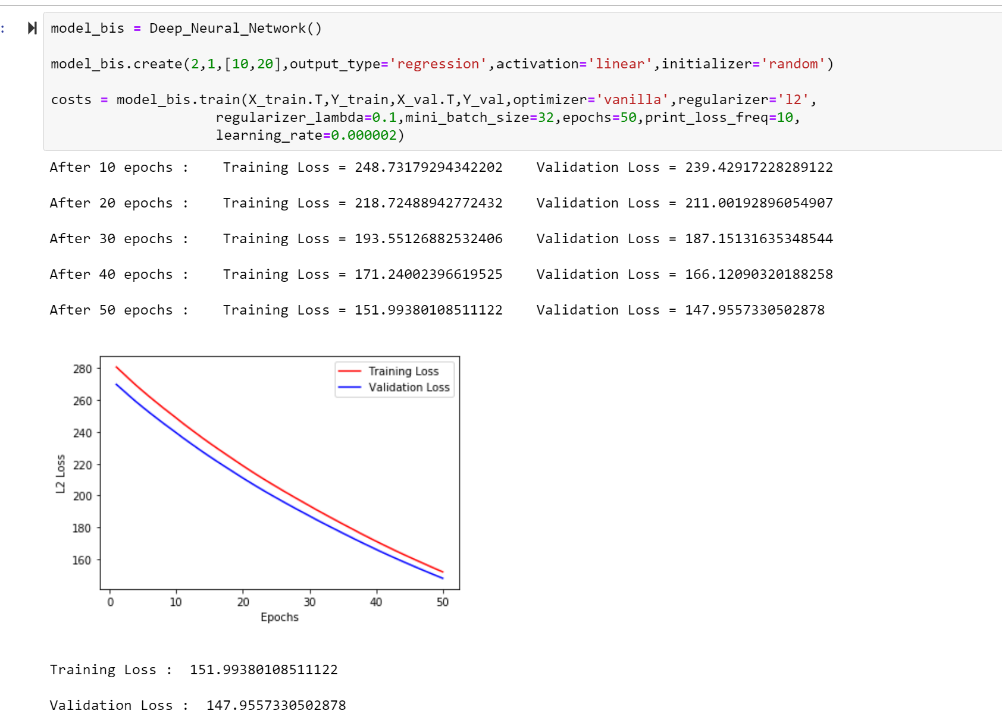

Figure 2

When the rate is too high, the opposite problem can appear, and we name it gradient explosion, that is, the minimum is not reached because we go over it:

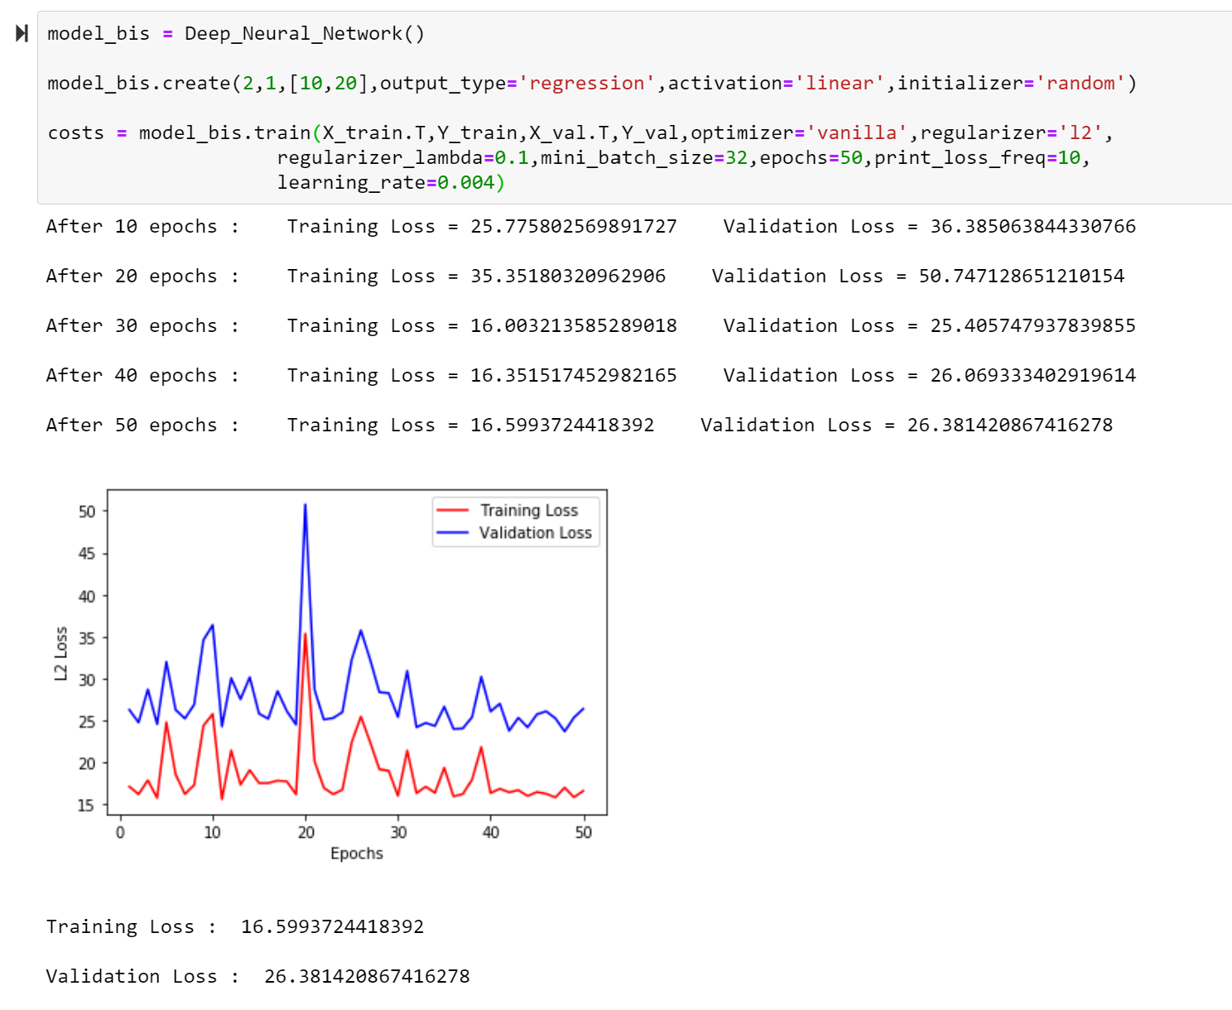

Figure 3

Once again, the choice of the optimization method is essential as well, as we can check:

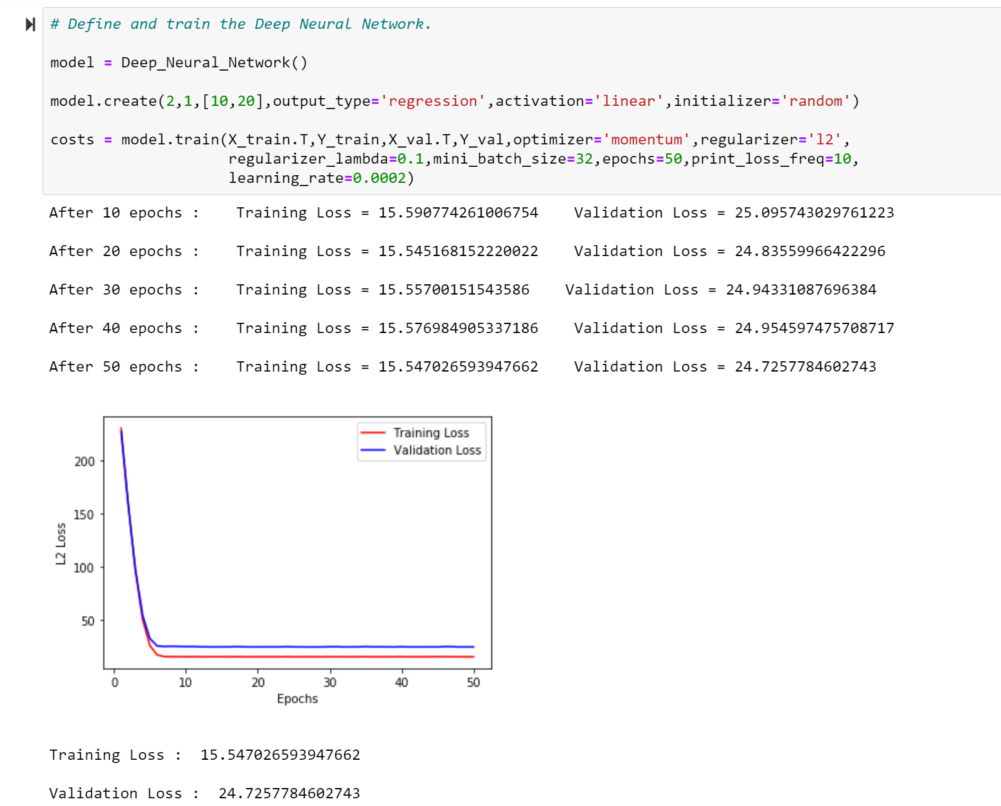

Figure 4

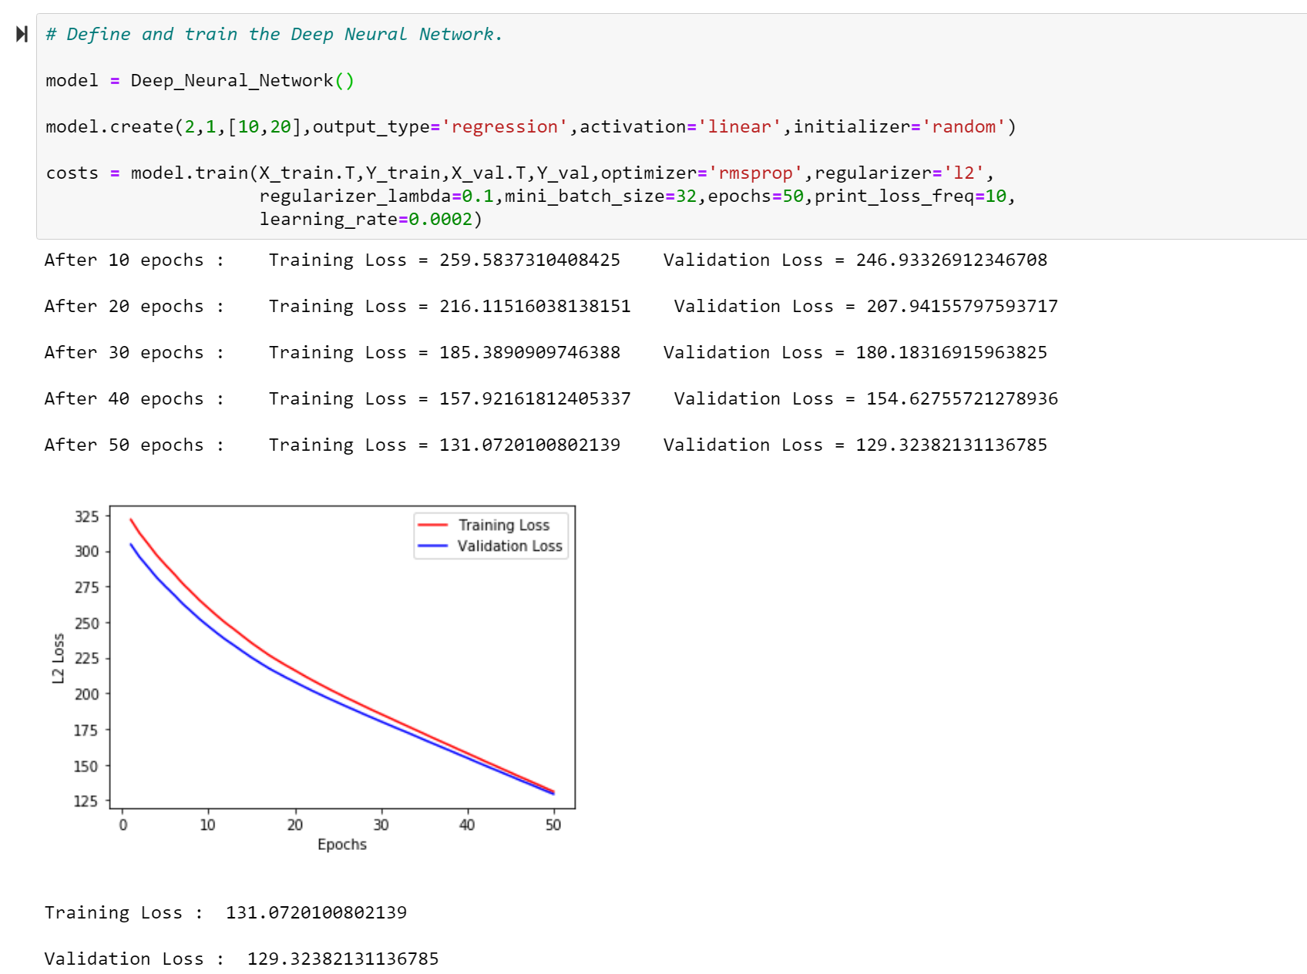

Figure 5

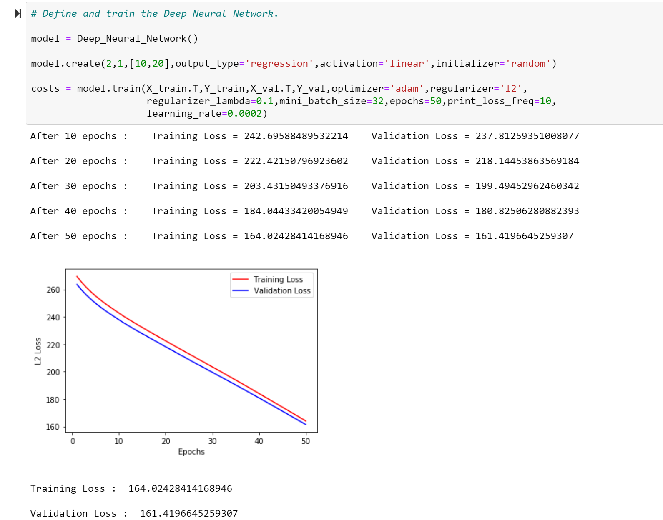

Figure 6

Once again, though, we should be conscious that working with neural networks is about trying different combinations of the parameters, functions, and optimization methods.

In fact, even though the RMSprop and ADAM method just above do not look promising, some few changes can lead to interesting results:

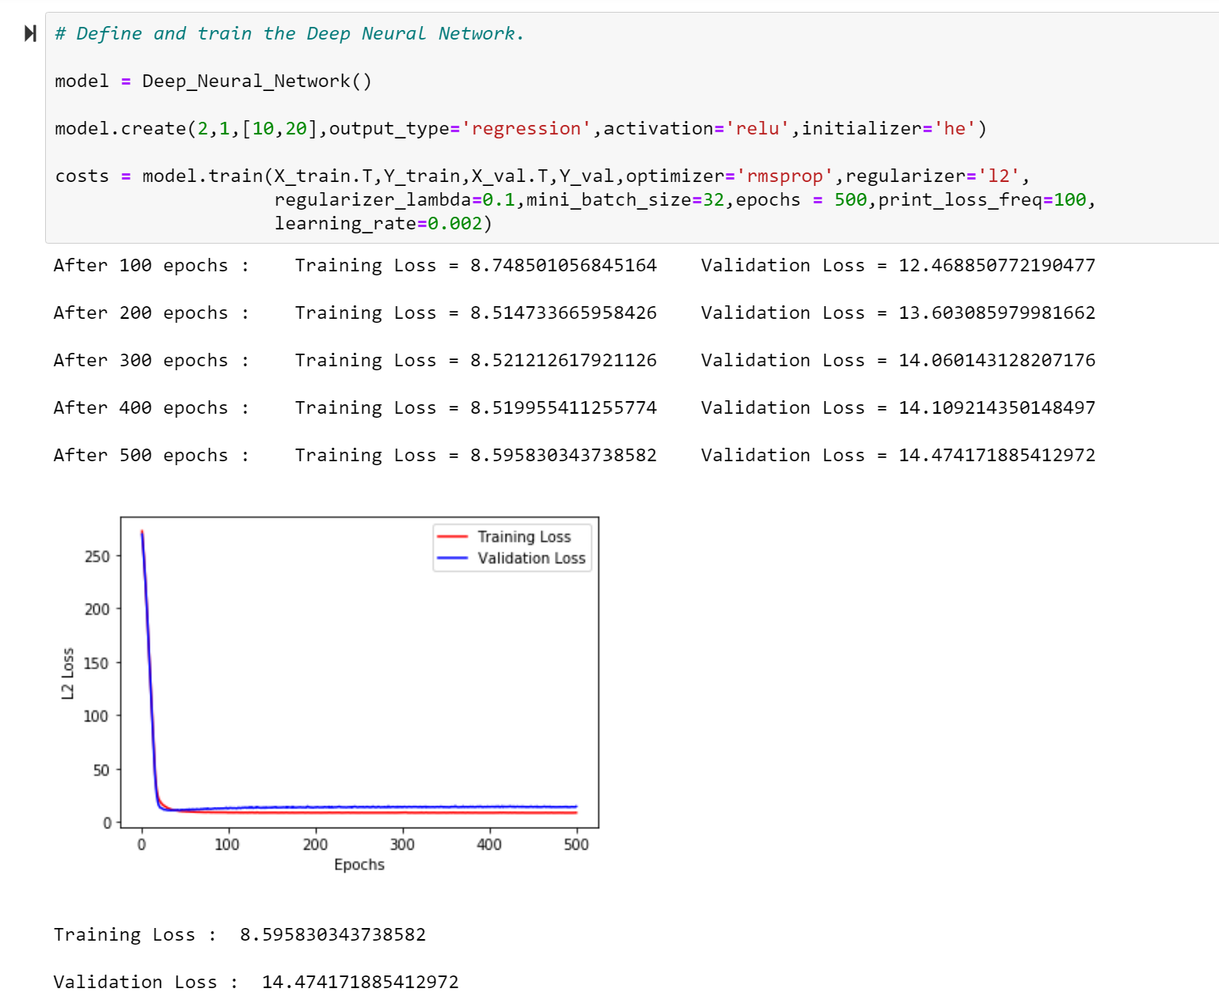

Figure 7

To assess the power of the neural networks, we need to compare them with other regression techniques. For the linear regression, I used SKLEARN and its built-in function LinearRegression. Since I used both a training and a validation set in the NN case (other than the test set), I will do the same split for SKLEARN as well and will therefore train the model only on the training data. In this way, I make sure that the model is trained on the same set:

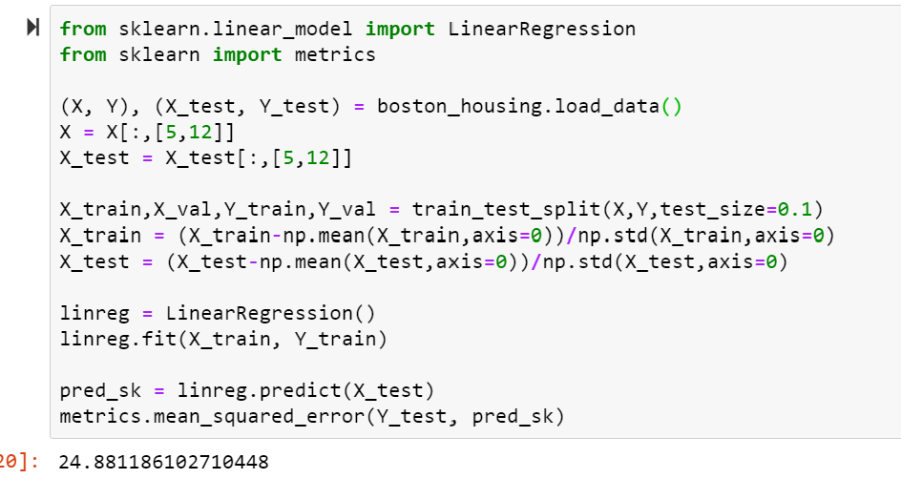

As we can see, in this case the Neural Network outperforms the Linear Regression. Does it always happen?

When the relation between the features and the response variable is exactly linear, it could happen that the linear regression fit works better than the Neural Network. In addition, Neural Networks need time to improve their performance. As we could see in figure 2, 5 and 6, poor combinations of the parameters and the algorithms can lead to undesirable results. What is then the take home message from Neural Networks, applied to regression?

Even though there is no doubt that Neural Networks can overperform Linear Regression (as it has happened here), thanks to their versability and ability to learn from the data, the choice is not straightforward. The main power of Linear regression, as one could tell, is interpretability. There is no simpler model than a linear regression model. From an independent variable (or more than one), we get a value for the response variable through the regression coefficients, that can easily (and analytically) be obtained, along with confidence intervals for their values, their significance, etc…

As always, the choice of a model depends on the purpose and the data. When the data are such that a linear fit makes sense, then my suggestion is to use that and forget about Neural Network, primarily if the aim is a statistical interpretation of the data. Why so?

As said, linear fits are easy to follow and obtain. All the needed information about the data can be obtained from these kinds of fits, and as long as the model makes sense (i.e., there is a real linear relation between the data), no information is lost. Additionally, Neural Networks are a more of black box, if compared to regression: the approximation given by a NN doesn’t give us any insight of the form of the relation standing between the features and the response. Is it always a problem?

As already said, it depends on the aim one has. If what we care about is just the result, or the prediction, or a probability… then Neural Networks are the choice to take. They can give fast (with the right choices) and better results than other models and are extremely adaptable to the data. For this reason, I personally believe Neural Networks should be almost only used for classification problems.

The reason I say this is that regression is generally made from statisticians to get information from the data, and many models have been implemented for this purpose to work the best as possible: I’m not only talking about linear fits, but also generalized linear models, additive models, etc.

When it comes to classification instead, we usually care about the result more than the reason why a certain result is given. If we want to understand if an image contains a certain number or represents a certain object, we do not necessarily want to know how much the colour inside a given pixel influences the Network, we just (for the majority) want to know the outcome.

Let’s not check how the Neural Networks perform in a classification scenario, where they can express the best their predictive ability. For this purpose, I will use the [Breast Cancer data](https://scikit-learn.org/stable/modules/generated/sklearn.datasets.load_breast_cancer.html), that can be obtained directly from SKLEARN.

Once again, I tried different number of hidden layers, different activation function, learning rates etc, to show again how versatile and easy to adapt Neural networks are. When it comes to binary classification, the main goal is obviously to be able to divide the two class in a way that the predictions we will make from the features values will give us values that belong to the right class, therefore, we can already see that a network like the one below already gives trustable results:

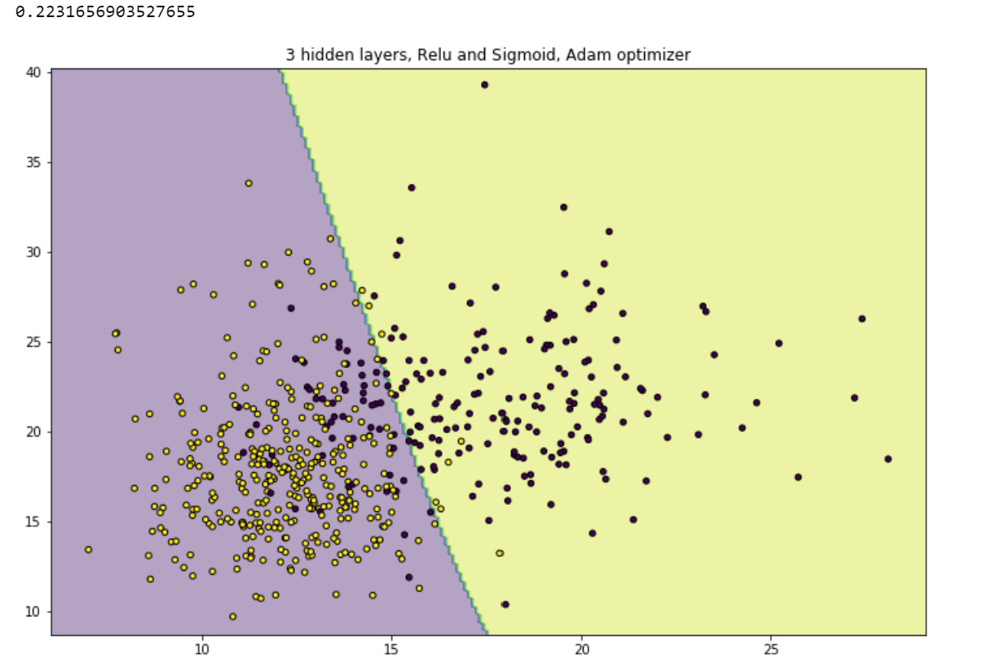

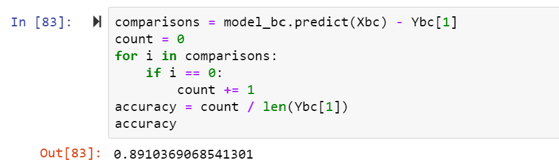

We can see that the Network is doing a decent job on this data, but it is not optimal. In this case, for the binary classification, different possible activation functions have been created:

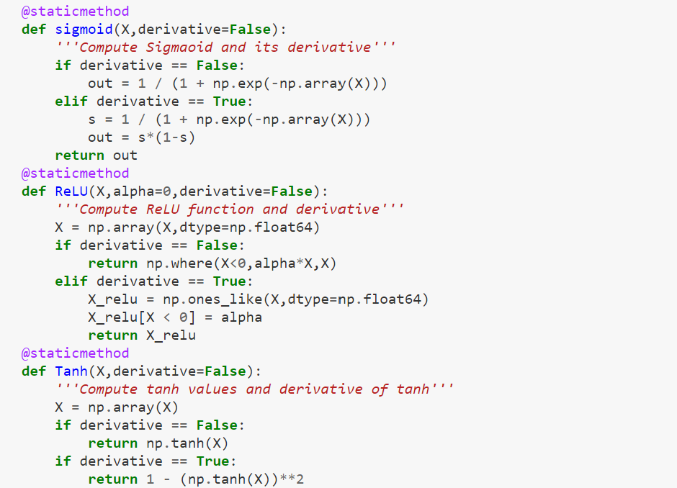

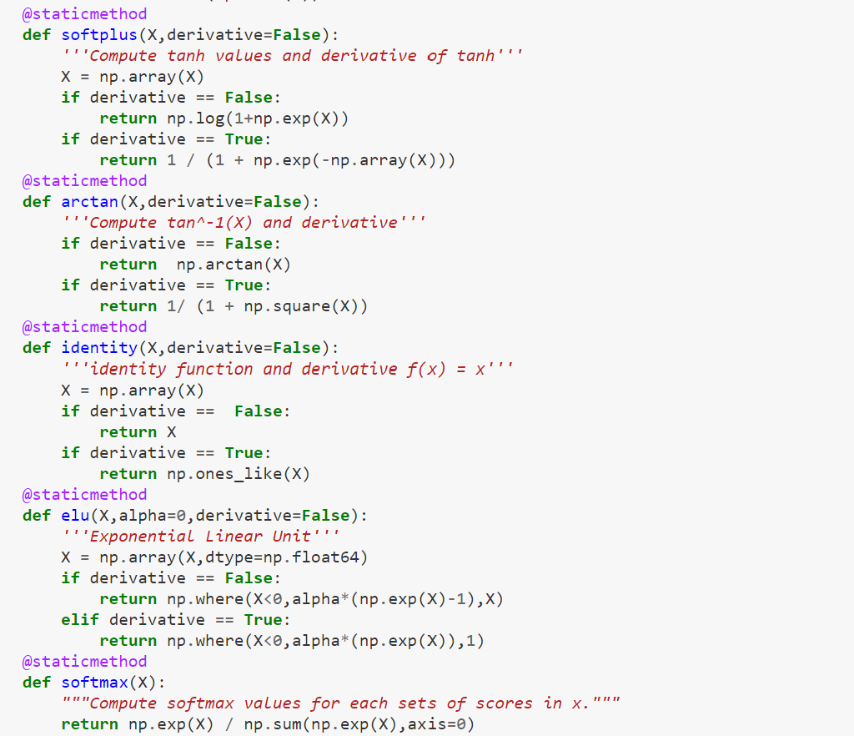

These functions, as explained before, are used in the forward propagation part of the code and used to define the relationship between the layers. Remember that the RELU function (as ELU) works by adding a parameter alpha to the output of the function, that thereby will be either 0 or a positive value. In this way, the obtained value is always a value greater than zero.

As different activation functions have been defined, different gradient optimization methods have been created as before. The code follows in the following page.

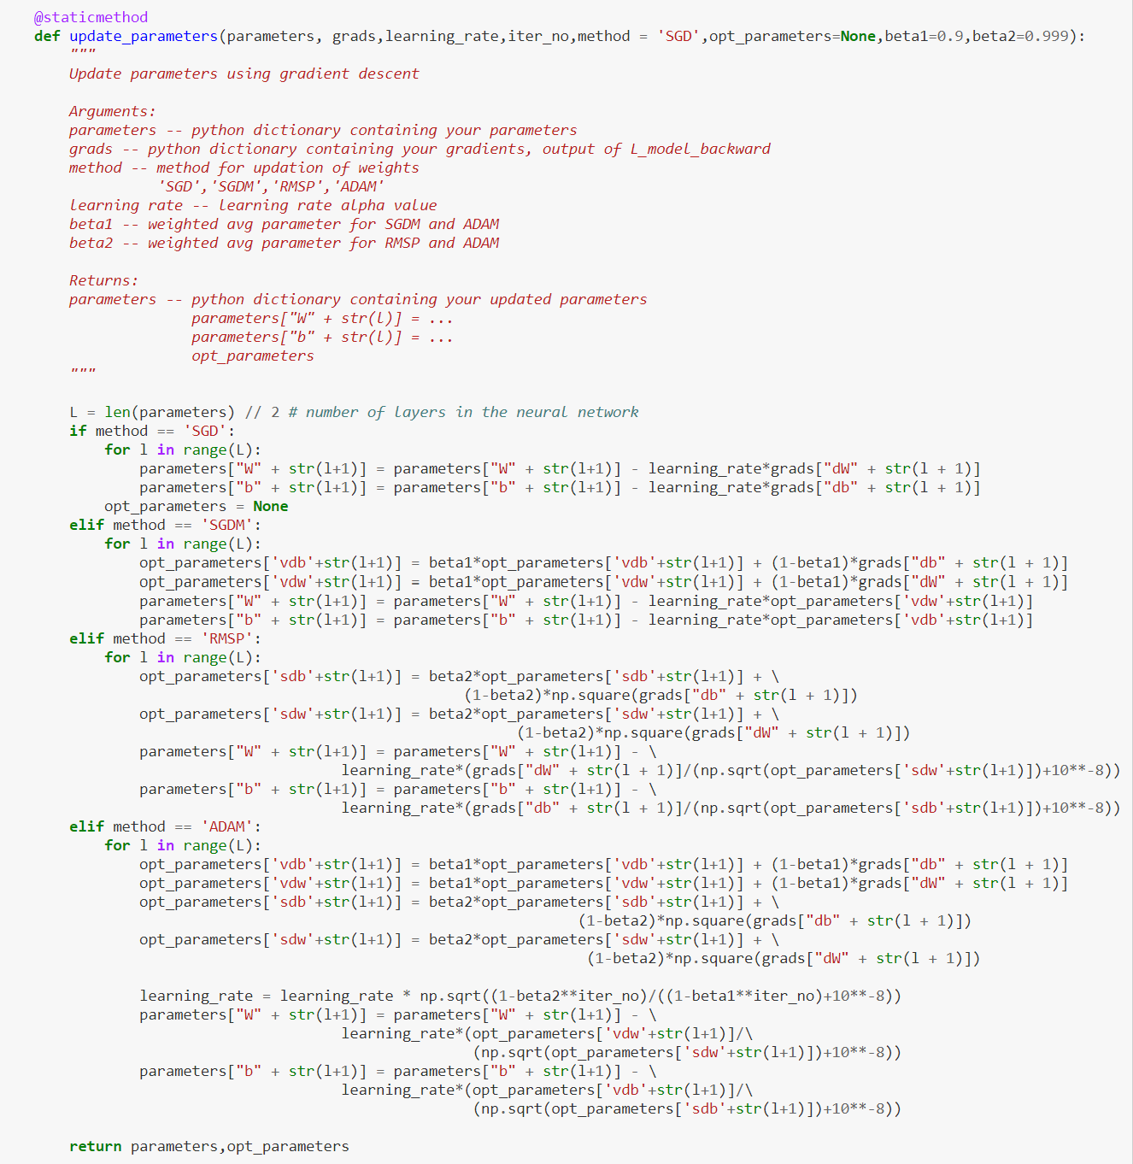

It is now time to check also for the classification scenario, how the results change when different choices are made. First, I can try different values for the learning rate and regularization parameter. These two, as said before, are the parameters that have the highest effect on the error made by the network. For the learning rate, this happens because it affects how big are the steps from a set of values of the weight to another. For the regularization parameter, this affect the importance a feature has on the output and if the penalty is too high, this will lead to bad results.

In the first place, I analysed the learning rate. At first, the set of values I considered was the following: [0.5, 0.1, 0.05, 0.025, 0.01, 0.005, 0.0025, 0.001, 0.0005, 0.00025, 0.00001]

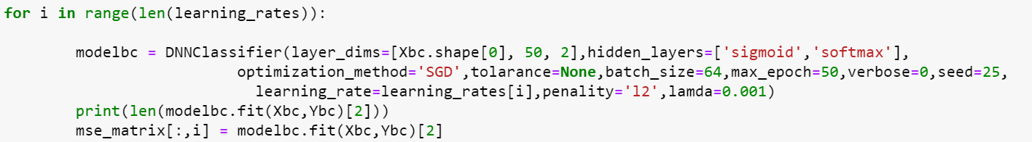

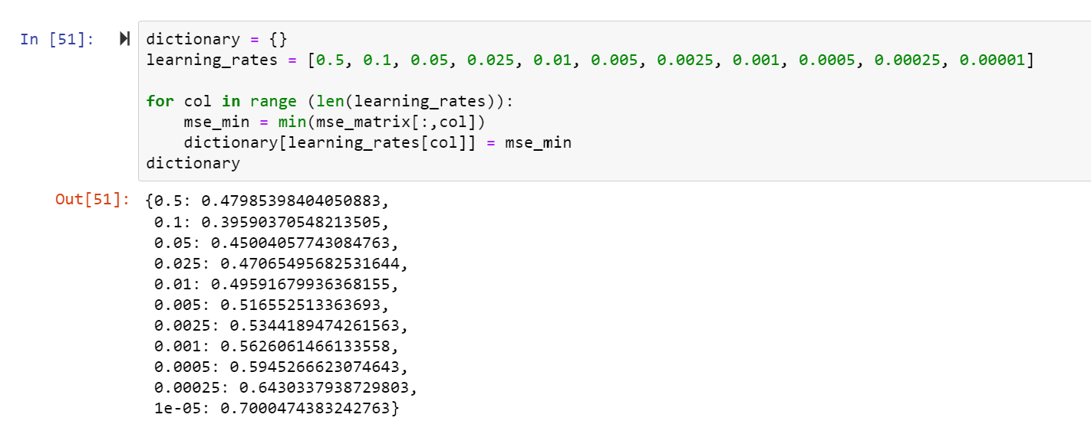

Which came with the following graph, showing that 0.5 probably too high, while 0.00001 is too low and leads to vanishing.

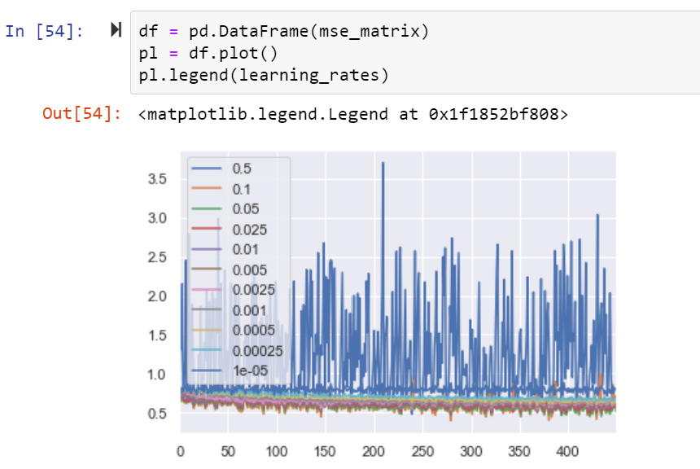

Therefore, I made some adjustments to have a better visualization, removing 0.05 and 0.00001 as possible values

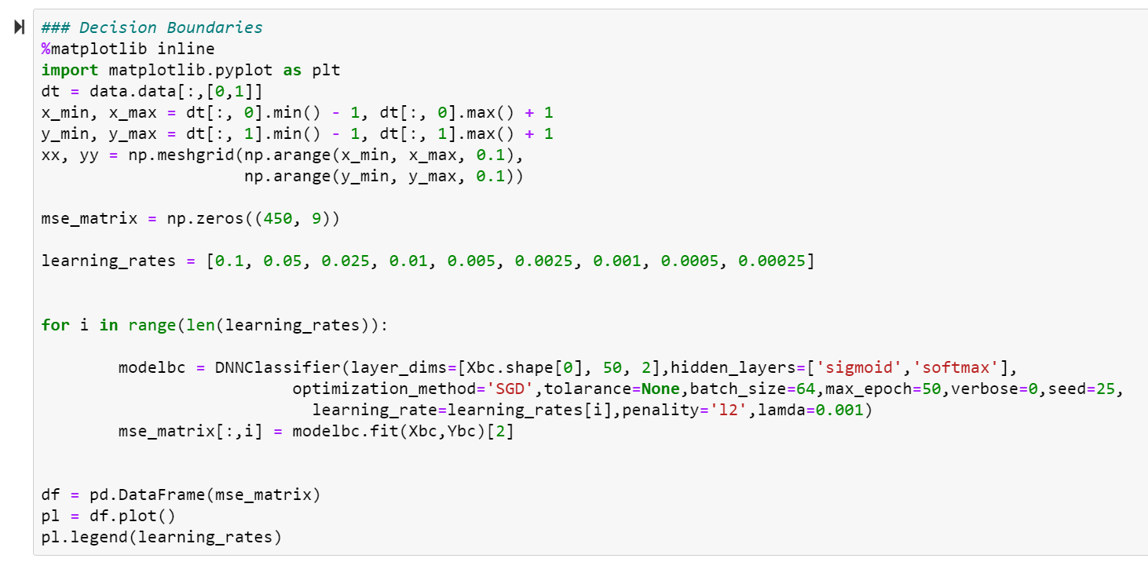

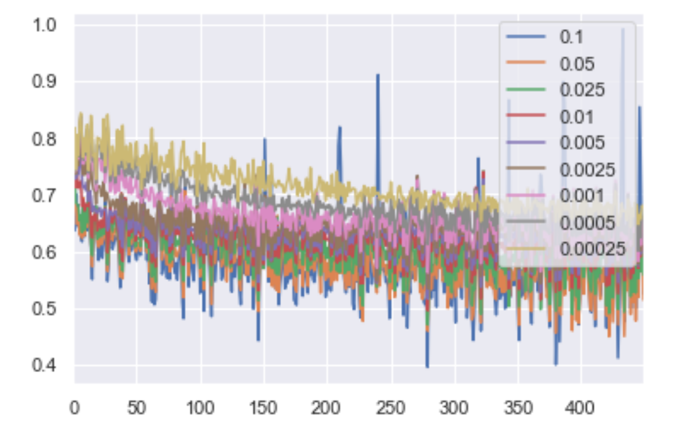

This plot is still not the easiest to understand, but we can easily see that the values of the MSEs do not go over 1, and that except for the value 0.1, the other values of the learning rates do not lead to too variable results. Moreover, we can observe that a value between 0.05 and 0.0025 could be the best in terms of MSE.

But what does it mean that the results are better or worse? Even though in the classification case the interpretation is quite straightforward, a plot can help anyway:

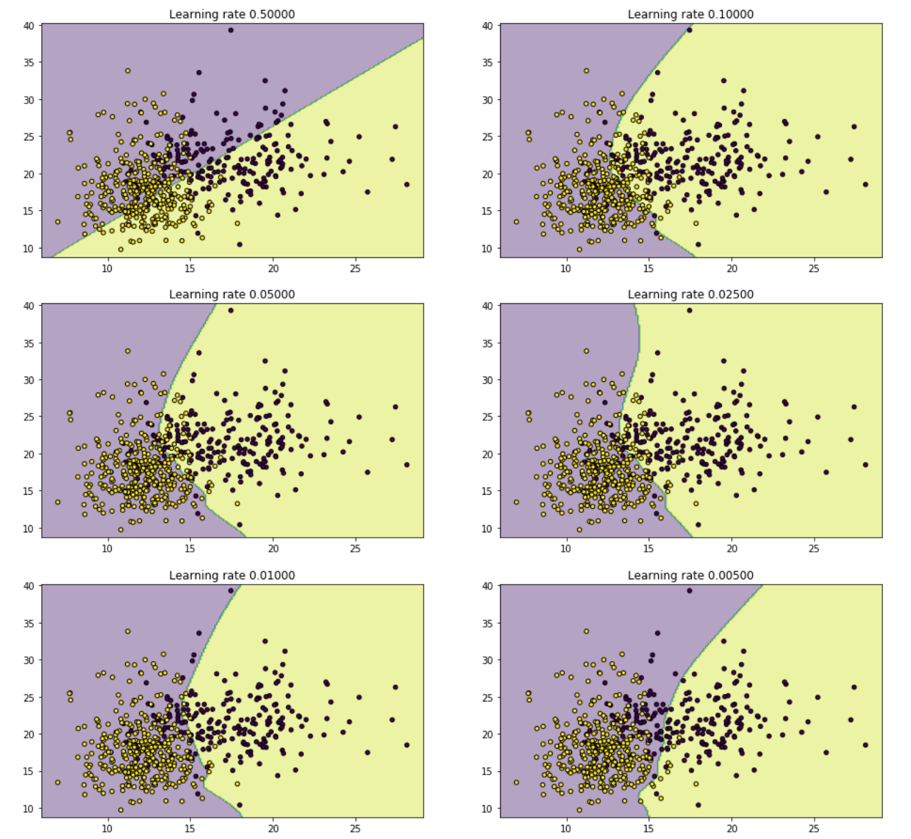

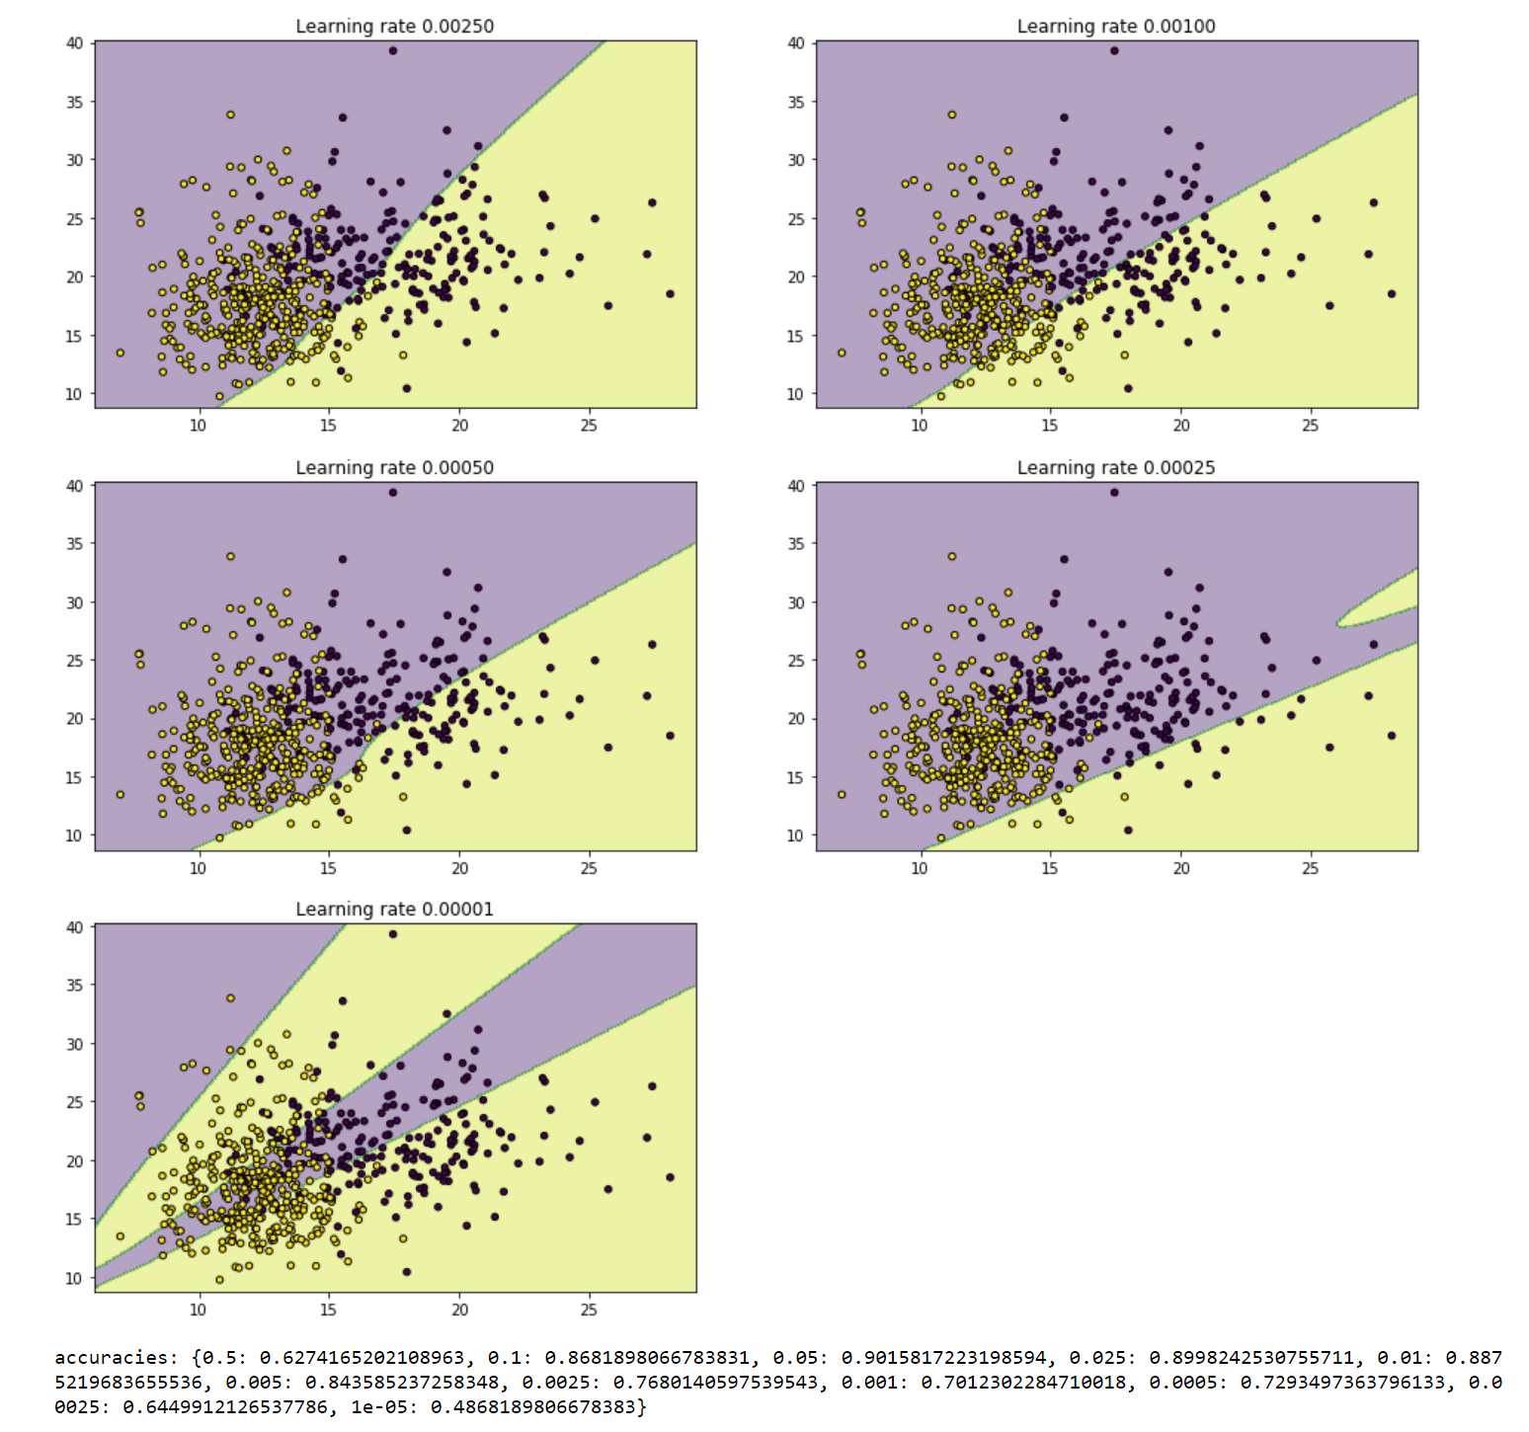

What we can derive from these plots is that as the learning rate changes, the boundary that delimits the two regions consequentially changes as well. For values that are too high or too low, there is not a good division between the two classes, while for values like 0.025 (which we will see is probably the best one) the two categories are clearly separated, which tells us that the predictions on the data will be accurate

As a consequence of that, I decided to check a possible best value for the learning rate, checking for the penalty term of a l2 regularization at the same time.

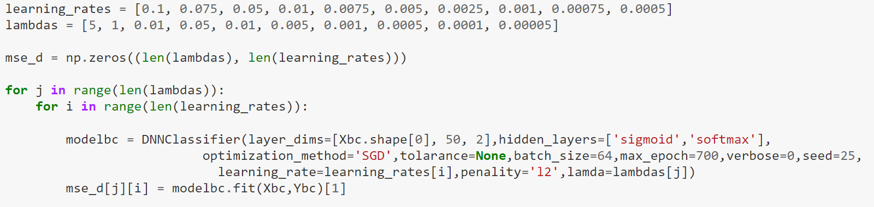

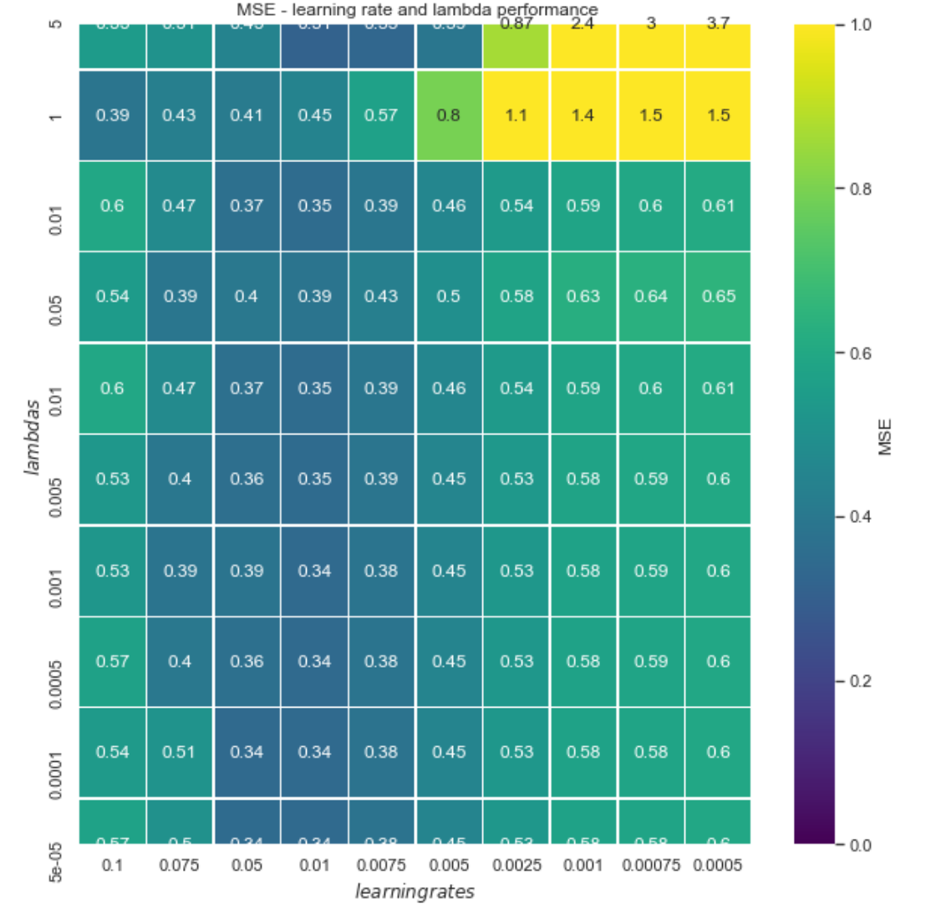

From the plot above, we can see that the choice of lambda, except for the values 5 and 1, does not affect too much the MSE, while the learning rate has a bigger impact (still not excessive). In this case, the best results in term of MSE are obtained for the value 0.01 on the learning rate and values lower than 0.001 on lambda.

Let’s now do a final check before trying different optimization methods, with the same values of lambda but values for the learning rate in a range between 0.05 and 0.0075



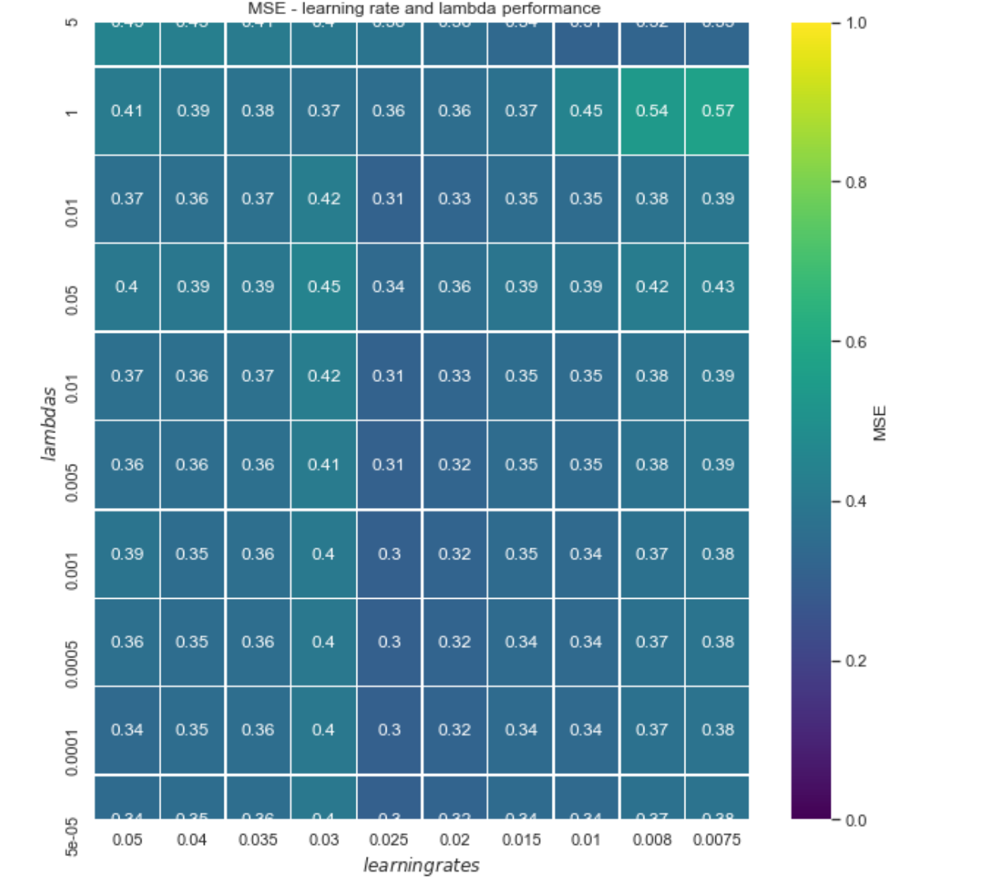

Finally, we can choose the value 0.025 for the learning rate, and 0.001 for lambda. Let’s now use these values to ‘play’ with the network.

First, I decided to try different optimization methods. I implemented the SGD, the SGD with momentum and the ADAM optimisations:

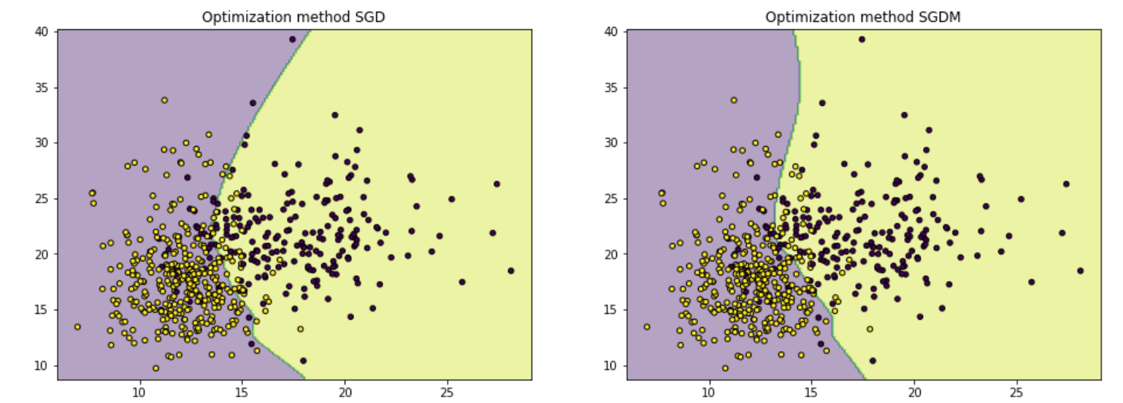

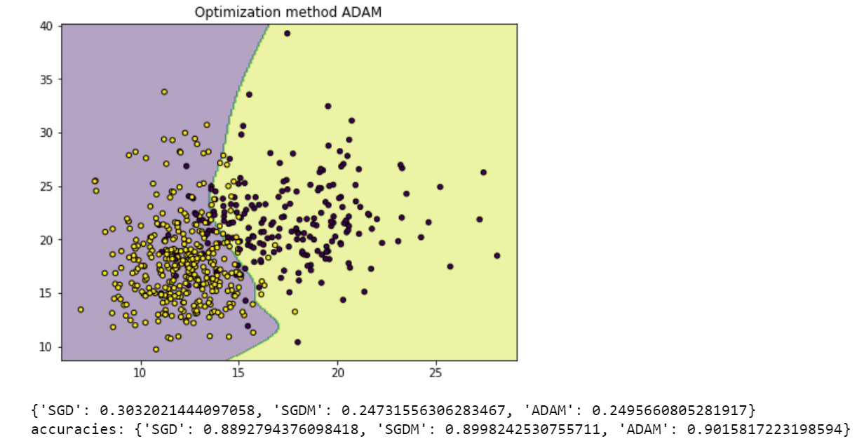

All the three methods seem to work good on the data and with the chosen values of the learning rate and the penalty term, but we could either choose the SGDM methods as this is the one that gives the lowest error, or the ADAM for the highest accuracy.

I decided to choose the ADAM optimization method to have a higher accuracy.

Finally, I can check how much the results change if we increase the number of nodes in the hidden layer (I only used one for simplicity, but as shown at page 26, we could also try a different number of hidden layers and different activation functions for each).

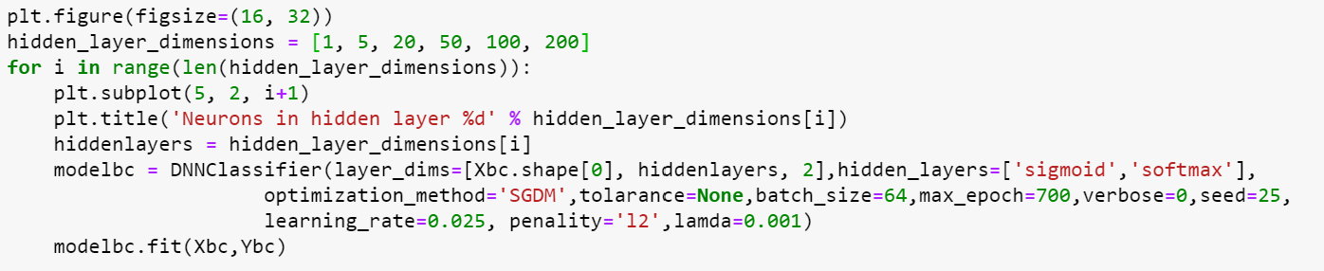

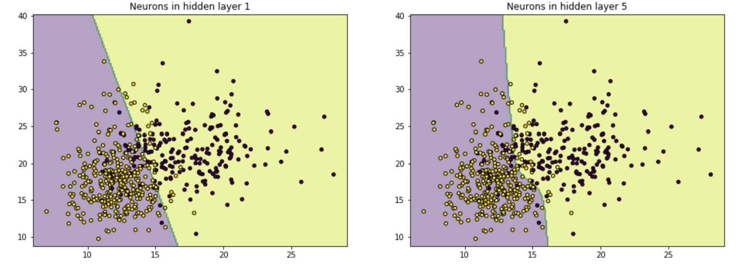

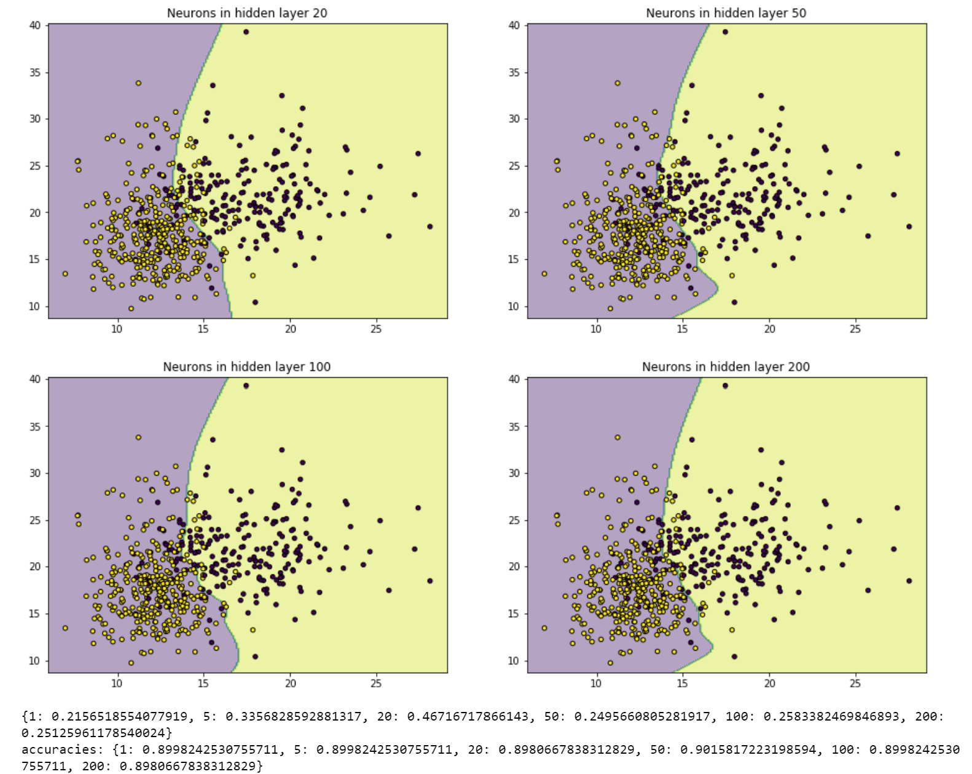

We can observe that, as always, going too low or too high in not necessarily a good choice. In fact, from 1 to 20 nodes in the hidden layer do not help minimizing the error, while from 100 or more the error starts increasing again. In this case, the same applies for the accuracy as well, therefore, for the values I used, the best choice will be to have 50 neurons in the hidden layer.

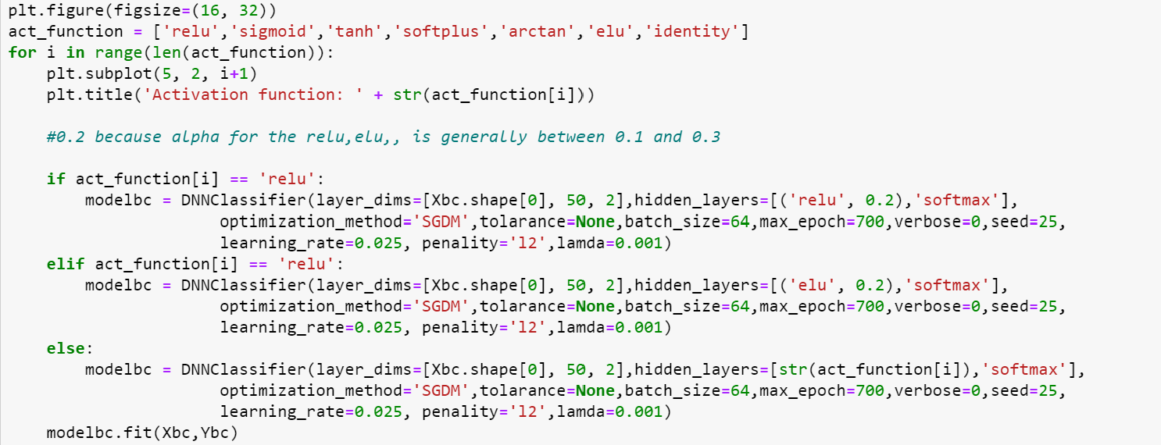

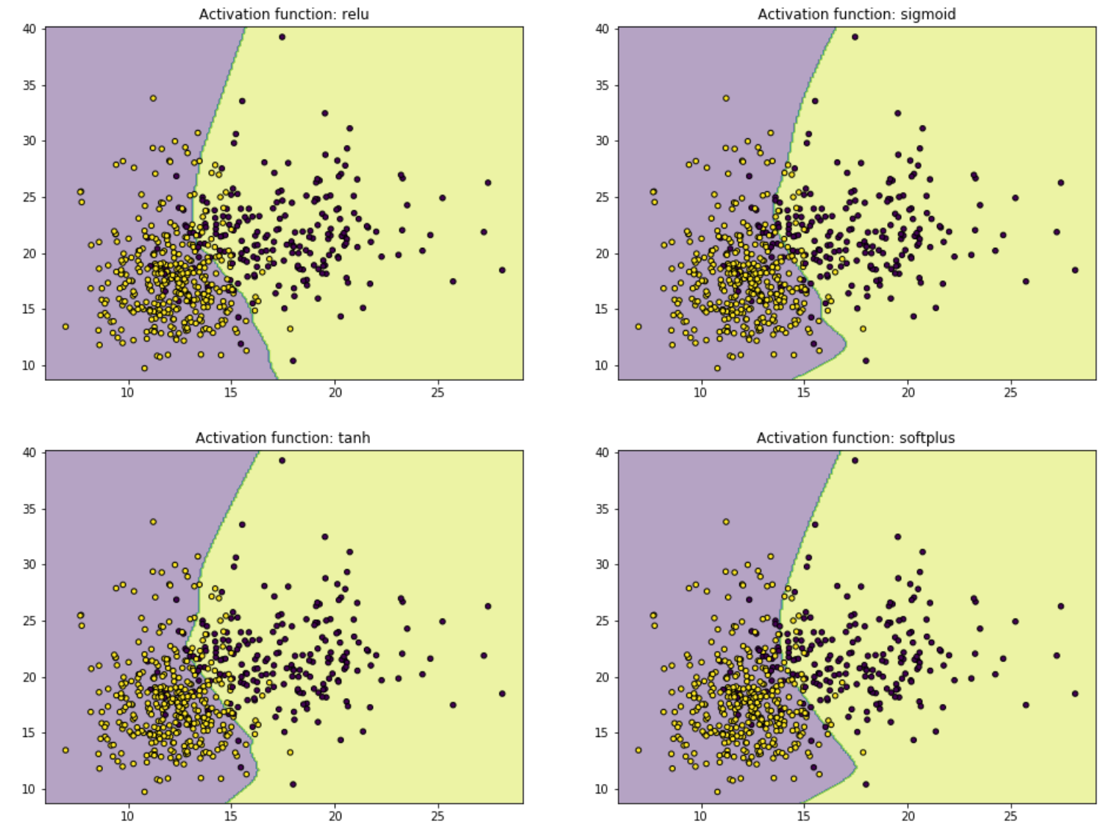 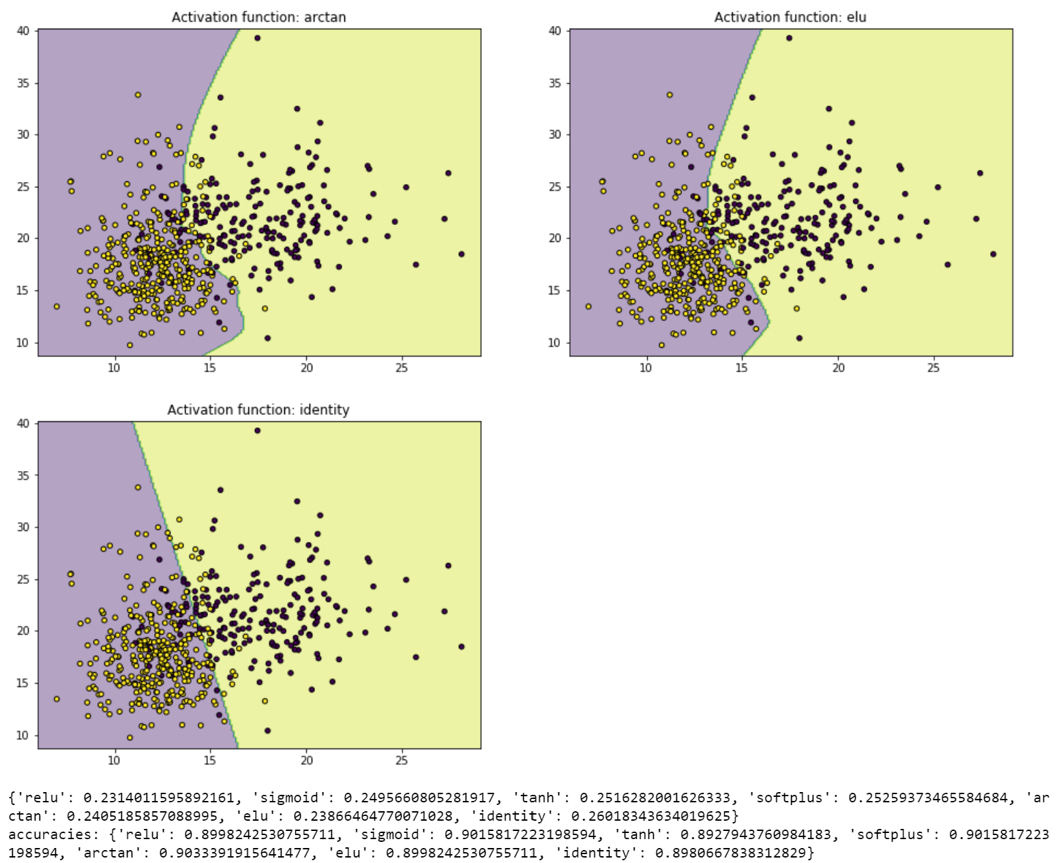

The seven possible activation functions I explored give results that are all quite similar to each other, but the *ELU* function is the one that gives the lowest error. Despite that, the highest accuracy is obtained with the *arctan* function, therefore I will keep that.

Coming to an end, we obtained very good results with: learning rate equals to 0.025, l2 regularization with penalty term equals to 0.001, ADAM as optimizer, 50 nodes in the hidden layer and the arctan function as the activation function.

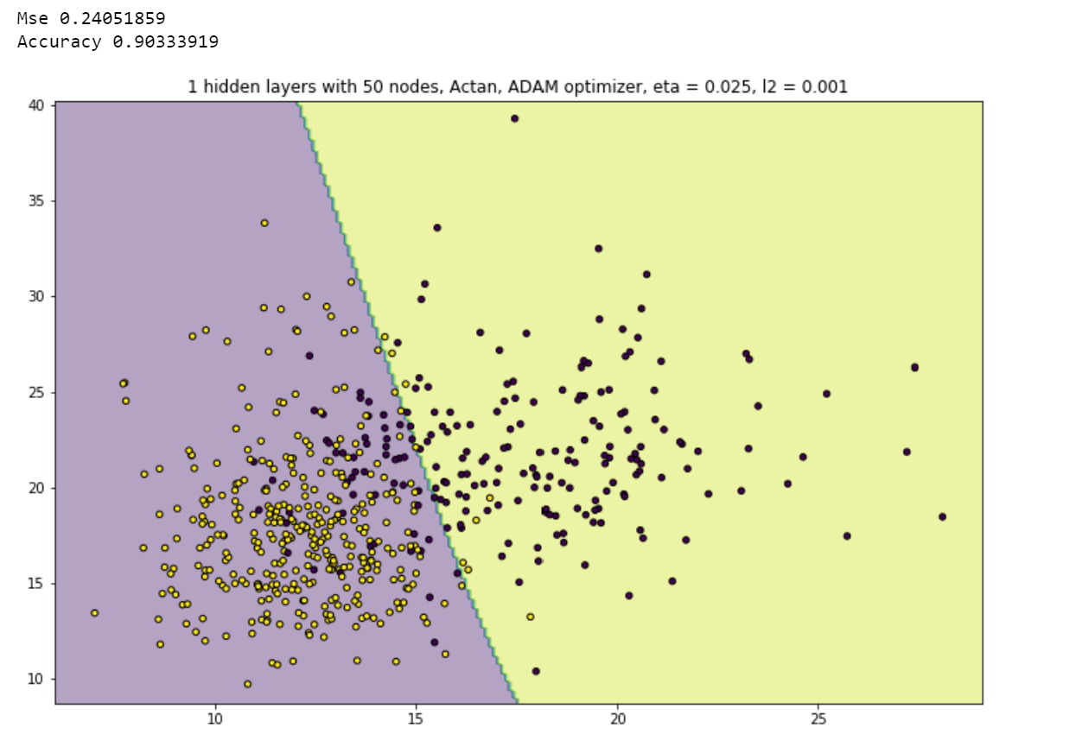

We can also see that the final Neural Network outperforms the standard Logistic Regression (from SKLEARN):

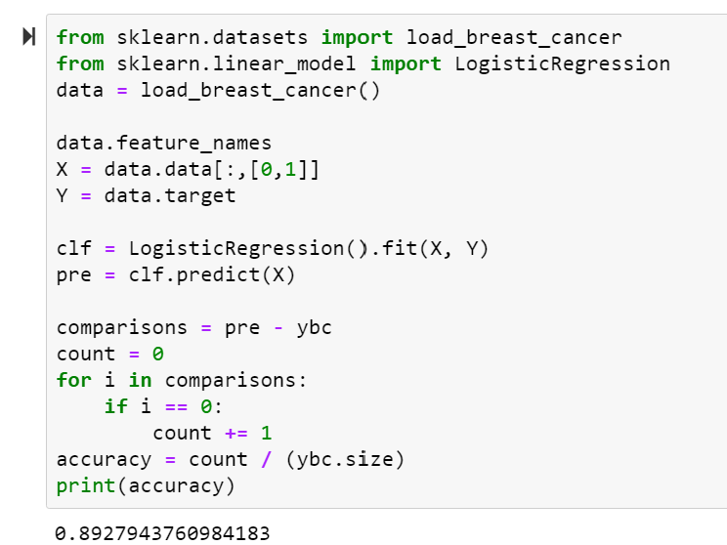

Is this the best combination?

**COCLUSION AND FINAL THOUGHTS**

As we could already establish, when working with neural networks there is no best combination, since different choices can lead to the same results, in terms of errors and predictions. Therefore, once again we can state that Neural Networks are mainly about trying. We need to accurately choose the tuning parameters, the functions, and the methods to use, but the only way we have to know how good our choice was is to compare it with different many other situations. Of course, the more situations we can compare, the better the final network will be and the more efficient it will be. Neural networks are surely powerful once they have been trained, since they will have learned how to manage the data and will give accurate results if trained well, but we still need to do lot of work behind in order to train them well.

To sum up, we could try to underline some general pros and cons of the networks:

**Advantages:**

* ability to learn on their own (circa) and generate output that is not limited to the input they provide
* they will learn from instances and adapt when a similar event occurs, thereby they can work through an event in real-time
* even if a neuron does not respond or some information is lost, the network is still able to detect the fault and generate the output (also, some functions as he RELU help us to have no *unfired* neurons)
* they can conduct multiple tasks in parallel without impacting the performance of the system
* they work even with incomplete knowledge
* have fault tolerance
* they work very well with nonlinear data with large number of inputs, for example, images
* they can e obtained with any number of inputs and layers

**Disadvantages and criticisms**

* They are mainly black boxes: we don’t know how much each independent variable is influencing the dependent variables
* Sometimes we would need more control over the details of the algorithm
* They usually require much more data than traditional algorithms (generally about thousand to millions of labelled samples)
* They are more complex in computing terms than traditional algorithms
* They can often lead to overfitting (as we can see in page 24). This happens because their size and structure are largely chosen through trials while training the network on the training dataset

To truly compact all the knowledge about NN, I think the best way is to consider the:

**NO FREE-LUNCH THEOREM**

This theorem is named after the phrase “there ain’t no such thing as a free lunch” and was proposed by David H. Wolpert and William G. Macready.

What this theorem says in simple words is that any one algorithm that searches for an optimal cost or fit solution in not universally superior to any other algorithm. What was stated was that “If an algorithm performs better than random search on some class of problems then it must perform worse than random searches on the remaining problems”. In short, *a superior black-box optimisation strategy is impossible.*

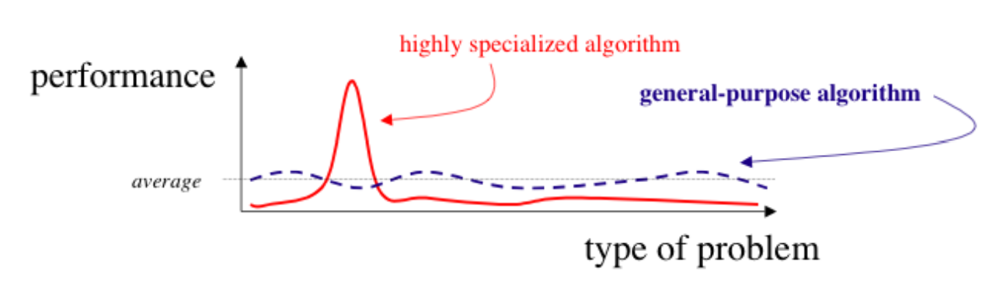

Ultimately, he only important question is, how do I find good solutions for my given cost function f? The proper answer is to start with a function we think is reasonable, then determine certain salient feature s of it and construct a search algorithm, specifically tailored to match those features.

What the theorem tells us is that we are generally not going to find off a best algorithm that fir perfectly any data, so we have to choose each time the one that fit them the best. For example, we will use Feed forward neural network for classifications, recurrent neural networks for time series, convolutional neural networks to better understand special information in the data…

To conclude, as always, there is no best method, but it always depends on the aim. Despite that, as said previously, I think that regression should not be done with NN when the interest falls on the data, their relationship and nature. On the other hand, if we merely just need to extract the final output, Neural Network are the choice to take, for their accuracy and ability to learn.

**REFERECES & CODE**

[*Bengio, Y. & Glorot X. [2010]. Understanding the difficulty of training deep feedforward neural networks*](http://proceedings.mlr.press/v9/glorot10a/glorot10a.pdf)

[*Saeed M. [2020, Nov. 4th] Gradient Descent in Python, Implementation and Theory [Blog Post]*](https://stackabuse.com/gradient-descent-in-python-implementation-and-theory/)

[*Bourret Sicotte X. [2018, Jun. 12] Ridge Regression and L2 Regularization*](https://xavierbourretsicotte.github.io/intro_ridge.html)

[*Yiu T. [2019, Jun. 2] Understanding Neural Networks [Blog Post]*](https://towardsdatascience.com/understanding-neural-networks-19020b758230)

*Hjorth-Jensen**M. (2021)* [*week 40*](https://compphysics.github.io/MachineLearning/doc/pub/week40/html/week40.html) *-* [*41*](https://compphysics.github.io/MachineLearning/doc/pub/week41/html/week41.html) *[lecture slides]*

[*Boldrini N. [2019, Mar. 1] Neural Networks: what are them? [Blog Post]*](https://www.ai4business.it/intelligenza-artificiale/deep-learning/reti-neurali/)

[*Shukla L. [2019] Training a Neural Network? Start Here! [Kaggle]*](https://www.kaggle.com/lavanyashukla01/training-a-neural-network-start-here#Make-Predictions)

*Nielsen M. (2018) Neural Networks and Deep Learning [Book]*

[*Hastie T.; Tibshirani R.; Friedman J. [2001] The Element of Statistical Learning (ESLII) Chapter 11*](https://web.stanford.edu/~hastie/Papers/ESLII.pdf)

*Howard, J. , Gugger, S. [2020].*Deep Learning for Coders with fastai & PyTorch*. O’Reilly Media [Book].*

[*Mijwel, M. [2018, Jan. 27]. Artificial Neural Networks Advantages and Disadvantages [Blog post]*](https://www.linkedin.com/pulse/artificial-neural-networks-advantages-disadvantages-maad-m-mijwel/)

[*Wolpert, D. H.; Macready, W. G. [1997]. "No Free Lunch Theorems for Optimization"*](https://ti.arc.nasa.gov/m/profile/dhw/papers/78.pdf)

Link to my codes: <https://github.com/simomira/project-2>